mimic human speech in bahasa indonesia using  
speech recognition and speech synthesis

By

Valens Prabagita Ivan Susilo

A Thesis

Submitted to the Faculty of Computing

President University

in Partial Fulfilment of the Requirements

for the Degree of Bachelor of Science

in Information Technology

Cikarang, Bekasi, Indonesia

October 2018

Copyright by

Valens Prabagita Ivan Susilo

2018

mimic human speech in bahasa indonesia using  
Speech recognition and speech synthesis

By

Valens Prabagita Ivan Susilo

Approved:

________________________________ ________________________________

Dr. Tjong Wan Sen, S.T., M.T. Drs. Nur Hadisukmana, M.Sc.

Thesis Advisor Program Head of Information Technology

________________________________

Ir. Rila Mandala, M.Eng., Ph.D.

Dean of Faculty of Computing

ABSTRACT

Everyday people use speech recognition and speech synthesis unconsciously. The technologies help them with their activities. With each technology can produce any kinds software related to speech. Combine both of technologies can produce many more. One of the combinations is mimic human speech. This research will discuss about Speech Recognition that use Convolutional Neural Network to as machine learning model and Speech Synthesis that use Concatenative Synthesis with syllables as speech unit. The purpose of this research is to develop application to collect, train, and mimic speech in Bahasa Indonesia. User can participate record their speech. The collected speech will be train to be used in the application to recognize the speech. After the collected speech is trained, User can mimic their speech by identify or recognize the speech and generate or synthesis the speech. The application to collect and mimic speech develops in website application.

Keywords: Mimic Speech, Speech Recognition, Speech Synthesis, Convolutional Neural Network, Concatenative Synthesis, Syllables, Bahasa Indonesia

ACKNOWLEDGMENTS

The author gratefully acknowledges the amazing supports, guidance and advices from:

1. Bebe, Annisa Feryannie Widya.
2. My beloved family, Ayah, Ibu, Mas Risky and Dek Lia.
3. B35TFR13NDZ0NE, Nisa, Marsel, Bora, Fira, Rai, Pindy, Oscar, and Michel.
4. Sangar Team, Mas Andreas, Mba Diana, Nisa, Alfian, and Aci
5. DV 14, Vovo, Gojal, Ariyel, Rino, Willy, Azmi, Damara, Atisah, Risda, Sonya, Dini, and Arizha.
6. My cool thesis lecturer, Mr. Wan Sen.
7. My second family, Van Lith XXII.
8. And you, yes you.

TABLE OF CONTENTS

Page

ACKNOWLEDGMENTS ............................................................................................. i

TABLE OF CONTENTS .............................................................................................. ii

LIST OF TABLES ........................................................................................................ v

LIST OF FIGURES .................................................................................................... vii

CHAPTER

I INTRODUCTION ............................................................................................ 1

1.1 Background ........................................................................................... 1  
 1.2 Problem Statement ................................................................................ 2  
 1.3 Research Objective ................................................................................ 2  
 1.4 Scope and Limitation ............................................................................. 2  
 1.5 Thesis Methodology .............................................................................. 3  
 1.6 Thesis Outline ........................................................................................ 4

II LITERATURE STUDY .................................................................................... 6

2.1 Speech Synthesis ................................................................................... 6 2.2 Syllable .................................................................................................. 7 2.3 Speech Recognition ............................................................................... 7 2.4 Mel Frequency Cepstral Coefficients .................................................... 8  
 2.4.1 Framing and Windowing ........................................................... 9  
 2.4.2 Discrete Fourier Transform and Power Spectrum ................... 10  
 2.4.3 Mel Filterbank ......................................................................... 10  
 2.4.4 Logarithm ................................................................................ 12  
 2.4.5 Discrete Cosine Transform ...................................................... 12  
 2.5 Machine Learning ................................................................................ 12  
 2.5.1 Supervised Learning ............................................................... 13  
 2.5.2 Unsupervised Learning ........................................................... 13  
 2.6 Neural Network ................................................................................... 14  
 2.7 Convolutional Neural Network ............................................................ 15  
 2.7.1 Pre-processing ......................................................................... 16  
 2.7.2 Convolution Layer .................................................................. 17  
 2.7.3 Max-pooling Layer ................................................................. 17  
 2.7.4 Fully-connected Layer ............................................................ 18  
 2.8 Related Work ....................................................................................... 18  
  
CHAPTER Page  
  
 2.8.1 Lyrebird .................................................................................. 18  
 2.8.2 Google Translate ..................................................................... 19

III SYSTEM ANALYSIS .................................................................................... 21  
 3.1 System Overview ................................................................................ 21  
 3.2 Functional Analysis ............................................................................. 21 3.3 Software and System Requirements .................................................... 22  
 3.4 System Architecture ............................................................................ 23  
 3.4.1 Use-Case Diagram .................................................................. 23  
 3.4.2 Use-Case Narrative ................................................................. 24  
 3.4.3 Activity Diagram ..................................................................... 28  
 3.4.3.1 Collect Application ..................................................... 28  
 3.4.3.2 Train Application ........................................................ 29  
 3.4.3.3 Mimic Application ...................................................... 30

IV SYSTEM DESIGN ......................................................................................... 32  
 4.1 User Interface Design .......................................................................... 32  
 4.1.1 Collect Application ................................................................. 32  
 4.1.1.1 Home Page .................................................................. 32  
 4.1.1.2 Syllables Page ............................................................. 33  
 4.1.2 Mimic Application .................................................................. 34  
 4.1.2.1 Home Page .................................................................. 34  
 4.1.2.2 Identify Page ............................................................... 35  
 4.1.2.3 Generate Page ............................................................. 35  
 4.2 Class Diagram ..................................................................................... 36  
 4.2.1 Collect Application ................................................................. 37  
 4.2.1.1 home ............................................................................ 37  
 4.2.1.2 syllables ...................................................................... 37  
 4.2.2 Train Application .................................................................... 38  
 4.2.2.1 model .......................................................................... 38  
 4.2.2.2 train ............................................................................ 38  
 4.2.3 Mimic Application .................................................................. 39  
 4.2.3.1 home ........................................................................... 39  
 4.2.3.2 identify ........................................................................ 39  
 4.2.3.3 generate ...................................................................... 40  
 4.2.4 Server ...................................................................................... 40  
 4.2.4.1 serverHanlder .............................................................. 41  
 4.2.4.2 createServer ................................................................ 42  
 4.2.5 Database .................................................................................. 43  
 4.2.5.1 connection ................................................................... 43  
 4.2.5.2 model .......................................................................... 43

CHAPTER Page  
  
 IV SYSTEM DEVELOPMENT ........................................................................... 44  
 5.1 User Interface Development ................................................................ 44  
 5.1.1 Collect Application ................................................................. 44  
 5.1.1.1 Home Page .................................................................. 44  
 5.1.1.2 Syllables Page ............................................................. 45  
 5.1.2 Mimic Application .................................................................. 46  
 5.1.2.1 Home Page .................................................................. 46  
 5.1.2.2 Identify Page ............................................................... 47  
 5.1.2.3 Generate Page ............................................................. 48  
 5.2 Application Details .............................................................................. 51 5.2.1 Collect Application ................................................................. 51  
 5.2.1.1 home ............................................................................ 51  
 5.2.1.2 syllables ...................................................................... 52  
 5.2.2 Train Application .................................................................... 53  
 5.2.2.1 model .......................................................................... 53  
 5.2.2.2 train ............................................................................ 54  
 5.2.3 Mimic Application .................................................................. 56  
 5.2.3.1 home ........................................................................... 56  
 5.2.3.2 identify ........................................................................ 57  
 5.2.3.3 generate ...................................................................... 58  
 5.2.4 Server ...................................................................................... 59  
 5.2.4.1 collect Router .............................................................. 60  
 5.2.4.2 identify Router ............................................................ 61  
 5.2.4.3 generate Router ........................................................... 62  
 5.2.4.4 serverHanlder .............................................................. 64  
 5.2.4.5 createServer ................................................................ 65  
 5.2.5 Database .................................................................................. 66  
 5.2.5.1 connection ................................................................... 66  
 5.2.5.2 model .......................................................................... 67

IV SYSTEM TESTING ....................................................................................... 68  
 6.1 Testing Environment ........................................................................... 68  
 6.2 Testing Scenario .................................................................................. 68  
 6.2.1 Collect Application ................................................................. 69  
 6.2.2 Train Application .................................................................... 70  
 6.2.3 Mimic Application .................................................................. 71

IV CONCLUSIONS AND FUTURE WORK ...................................................... 84  
 7.1 Conclusion ........................................................................................... 84  
 7.2 Future Work ........................................................................................ 84

REFERENCES ............................................................................................................ xi

LIST OF TABLES

TABLE Page

3.1 Collect application functionality table ............................................................. 21

3.2 Train application functionality table ................................................................ 21

3.3 Mimic application functionality table .............................................................. 22

3.4 Use-case narrative – Access Collect application .............................................. 24

3.5 Use-case narrative – Record Speech ................................................................ 25

3.6 Use-case narrative – Train model ..................................................................... 25

3.7 Use-case narrative – Access Mimic application ............................................... 26

3.8 Use-case narrative – Identify speech ................................................................ 27

3.9 Use-case narrative – Generate speech .............................................................. 27

4.1 Collect Home page description ........................................................................ 33

4.2 Collect Syllables page description ................................................................... 33

4.3 Mimic Home page description ......................................................................... 34

4.4 Mimic Identify page description ...................................................................... 35

4.5 Mimic Generate page description .................................................................... 36

6.1 Collect application scenarios ........................................................................... 69

6.2 Train application scenarios .............................................................................. 70

6.3 Mimic application scenarios ............................................................................ 72

6.4 Tester 1 results on noisy background ............................................................... 73

6.5 Tester 1 results on semi noisy background ...................................................... 74

6.6 Tester 1 results on not noisy background ......................................................... 75

TABLE Page

6.7 Tester 2 results on noisy background ............................................................... 75

6.8 Tester 2 results on semi noisy background ...................................................... 76

6.9 Tester 2 results on not noisy background ......................................................... 77

6.10 Tester 3 results on noisy background ............................................................. 77

6.11 Tester 3 results on semi noisy background .................................................... 78

6.12 Tester 3 results on not noisy background ....................................................... 79

6.13 Tester 4 results on noisy background ............................................................. 79

6.14 Tester 4 results on semi noisy background .................................................... 80

6.15 Tester 4 results on not noisy background ....................................................... 81

LIST OF FIGURES

FIGURE Page

1.1 RAD Diagram [3] .............................................................................................. 3

2.1 Sound sampling process [12] ............................................................................. 8

2.2 40 Filterbank from 0 Hz to 4000 [14] .............................................................. 11

2.3 Neural network to find estimated price from specific input [19] ..................... 14

2.4 Computer read an image [19] ........................................................................... 15

2.5 The basic neural network where it only recognizes the

object on the center (top), but doesn't on another surface (bottom) [19] ......... 15

2.6 Before (left) and after (right) pre-processing image [7] ................................... 16

2.7 Two example of CNN for its own problem that trying

to be solved [19, 20] ......................................................................................... 16

2.8 Convolution process on single tile (top) and overview

all tiles (bottom) [19] ....................................................................................... 17

2.9 Max-pooling layer with 2x2 pool size and 2 stride [19] .................................. 17

2.10 Fully-connected layer in CNN[19] ................................................................ 18

2.11 Screenshot of Lyrebird in website [21] .......................................................... 19

2.12 Screenshot of Google Translate in website [22] ............................................ 19

3.1 Use-case diagram ............................................................................................. 24

3.2 Collect application activity diagram ................................................................ 29

3.3 Train application activity diagram .................................................................. 30

3.4 Mimic application activity diagram ................................................................ 31

4.1 Collect Home page ........................................................................................... 32

FIGURE Page

4.2 Collect Syllables page ...................................................................................... 33

4.3 Mimic Home page ........................................................................................... 34

4.4 Mimic Identify page ......................................................................................... 35

4.5 Mimic Generate page ....................................................................................... 36

4.6 Collect application class diagram .................................................................... 37

4.7 Train application class diagram ....................................................................... 38

4.8 Mimic application class diagram ..................................................................... 40

4.9 Server class diagram ........................................................................................ 42

4.10 Database class diagram .................................................................................. 43

5.1 Collect Home Page .......................................................................................... 44

5.2 Collect Syllables page with ‘a’ syllable ........................................................... 45

5.3 Collect Syllables page after record process is finish ........................................ 46

5.4 Mimic Home page ........................................................................................... 46

5.5 Mimic Identify page ......................................................................................... 48

5.6 Mimic Identify page alert user indicating identify process

in the server is finish ........................................................................................ 48

5.7 Mimic Identify page alert user indicating there is

no value in Input element ................................................................................. 48

5.8 Mimic Generate page ....................................................................................... 49

5.9 Mimic Generate page play the generate speech

after generated process success ....................................................................... 50

5.10 Mimic Generate page alert user indicating there is

no value in textarea element ......................................................................... 50

FIGURE Page

5.11 Mimic Generate page alert user indicating there is

error in the generate process .......................................................................... 50

5.12 Collect home html code ................................................................................. 51

5.13 Collect syllables btnRecord code ................................................................... 53

5.14 Train model modelML code .......................................................................... 54

5.15 Some part of Train train extractWav code ..................................................... 56

5.16 Mimic home html code .................................................................................. 57

5.17 Mimic identify xhrPostIdentifySPeech code ................................................. 58

5.18 Mimic generate xhrGetSpeechId code ........................................................... 59

5.19 Server collect router uploadCollect code ....................................................... 60

5.20 Some part of Server identify router identifySpeech code .............................. 62

5.21 Some part of Server generate router generateSpeech code ............................ 63

5.22 Server serverHandler code ............................................................................. 65

5.23 Server createServer code ............................................................................... 66

5.24 Database connection code .............................................................................. 66

5.25 Database model code ..................................................................................... 67

6.1 Screenshot of process upload record request scenario

from Collect application .................................................................................. 70

6.2 Screenshot of load and split collected data and extract

the data scenarios from Train application ........................................................ 71

6.3 Screenshot of process identify speech on Identify request

scenario from Mimic application ..................................................................... 73

FIGURE Page

6.4 Screenshot of Tester 1 with a and i syllables on

not noisy background. ..................................................................................... 82

# INTRODUCTION

## Background

“Ok Google, play some music”. “Siri, what should I eat for lunch?”. Everyday people use their artificial assistance to boost their activities. People very like to use it because they just asked to their device and then in seconds, the wish is granted. It seems like, people are talking to the computer. The truth is, speech recognition takes big role with the help of machine learning. Google Assistance, Apple Siri, Microsoft Cortana, Amazon Alexa, and others have thousands of speech data to be analysed with the machine learning and they easily add data by collecting people speech from the assistance with permission.

If speech recognition is the process to get data by analysed speech, the opposite of speech recognition is speech synthesis, the process to produce artificial speech. Therefore, speech recognition is known as speech-to-text and speech synthesis is known as text-to-speech. “Hey Cortana, read my email” command make artificial assistance generate speech from the email text. With each technology can produce any kinds software related to speech. Combine both of technologies can produce many more. One of the combinations is mimic human speech.

## Problem Statement

This research aims to develop application which can be used to collect speech data, train machine learning model with collected data and mimic speech in Bahasa Indonesia. The application to collect and mimic speech develops in website application. The application can recognize the speech and generate speech from text.

## Research Objective

This research sees an opportunity to implement speech recognition and speech synthesis to create a mimic speech.

## Scope and Limitation

This research focuses on developing an application which will be able to:

1. Perform collecting data.
2. Perform train model.
3. Perform speech recognition.
4. Perform speech synthesis.

The limitations of this application are as following:

1. There are 9 selected syllables to be used in the application, a, i, na, ma, mu, di, ri, and ku.
2. Recorded speech in 1 second, with sample rate 16000 and mono sound.
3. Speech recognition data is taken from recorded speech in Bahasa Indonesia.
4. Speech synthesis data is taken from saved speech, result from speech recognition.
5. Application is developed as website application.

## Thesis Methodology

Rapid Application Development (RAD) methodology will be used in the development of this application. RAD method is a term originally used to describe a software development process introduced by James Martin in 1991 [1]. RAD method is a methodology to develop software that requires minimum planning for rapid prototyping. As James Martin says, RAD is a lifecycle used for development of software which provides faster development and also gives high quality software then, by using traditional software development lifecycle. In short, RAD is the process which accelerates the cycle of development of an application [2]. The RAD diagram is depicted in Figure 1.1.

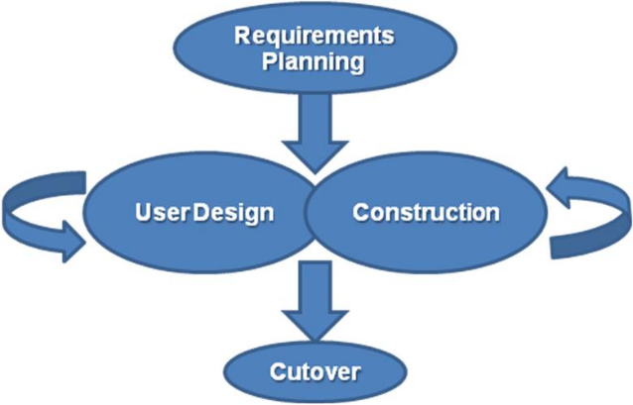

Figure 1.1 RAD Diagram [3].

The RAD model implemented in this thesis will consists of four major phases:

1. Requirement Planning Phase

This phase combines elements of the system planning and systems analysis phases of the Systems Development Life Cycle (SDLC) [3].

1. User Design Phase

During this phase, users interact with systems analysts and develop models and prototypes that represent all system processes, inputs, and outputs. This phase is a continuous interactive process that allows users to understand, modify, and eventually approve a working model of the system that meets their needs [3].

1. Construction Phase

This phase focuses on program and application development task similar to the SDLC. In RAD, however, users continue to participate and can still suggest changes or improvements as actual screens or reports are developed. Its tasks are programming and application development, coding, unit-integration and system testing [3].

1. Cut Over Phase

This final phase resembles the final tasks in the SDLC implementation phase, including data conversion, testing, changeover to the new system, and user training. Compared with traditional methods, the entire process is compressed. As a result, the new system is built, delivered, and placed in operation much sooner [3].

## Thesis Outline

The thesis consists of seven chapters, which are as follow:

1. Chapter I: Introduction

This chapter introduce the research background, problem, and objective. It also explains the research scope and limitation, method to achieve the objective.

1. Chapter II: Literature Study

This chapter contain the literature study that related to the research background.

1. Chapter III: System Analysis

This chapter explains the analysis of the application – both in its function and behaviour, in order to fulfil the prescribed requirements.

1. Chapter IV: System Design

This chapter explains the system design of interfaces and class diagram based on the previous chapter that will be used in the next chapter.

1. Chapter V: System Development

This chapter explains the system development of interfaces and code details on the application.

1. Chapter VI: System Testing

This chapter ensures the application system runs well by evaluating all the features, and making sure the system fulfils its function requirements.

1. Chapter VII: Conclusion and Future Work

This chapter sums up this research and also suggestion for future research work.

# LITERATURE STUDY

## Speech Synthesis

Speech synthesis is the process with the goal of building a system that can start with text and produce speech automatically [4]. As in mimic speech, the speech is taken from recognized speech, concatenative synthesis can be the best approach.

Concatenative synthesis connecting pre-recorded natural utterances is probably the easiest way to produce intelligible and natural sounding synthetic speech. One of the most important aspects in concatenative synthesis is to find correct unit length. The selection is usually a trade-off between longer and shorter units. With longer units, high naturalness, less concatenation points and good control of coarticulation are achieved, but the number of required units and memory is increased. With shorter units, less memory is needed, but the sample collecting and labelling procedures become more difficult and complex.

In present systems units used are usually words, syllables, demisyllables, phonemes, diphones, and sometimes even triphones [5]. As there aren’t found any exact amount of Bahasa Indonesia phonemes, syllables can be the best options for the speech unit.

## Syllable

Syllable is a unit of pronunciation having one vowel sound, with or without surrounding consonants, forming the whole or a part of a word; for example, there are two syllables in water and three in inferno [6]. As in Bahasa Indonesia there are many rules to decoding a word to get the syllable. It constructed from 5 *vokal* (vowel), 21 *konsonan* (consonants), 4 *diftong* (diphthong), 4 *gabungan huruf konsonan* (cluster) [7].

## Speech Recognition

Speech recognition is the process of converting a speech signal to a sequence of words, by means of an algorithm implemented as a computer program. [8]. There are so many techniques and approaches [8, 9] to do speech recognition, it depends on the problem that going to be solved in optimum way. In mimic speech, as a speech is constructed by word and word constructed by syllables, convolutional neural network is one of optimum way to word spotting [10].

The way that computer understand the speech or signal is by sound sampling. Sound sampling is taking a reading thousands of times a second and recording a number representing the height of the sound wave at that point in time [12]. Nyquist sampling theorem provides a prescription for the nominal sampling interval required to avoid aliasing. The sampling frequency should be at least twice the highest frequency contained in the signal [11].

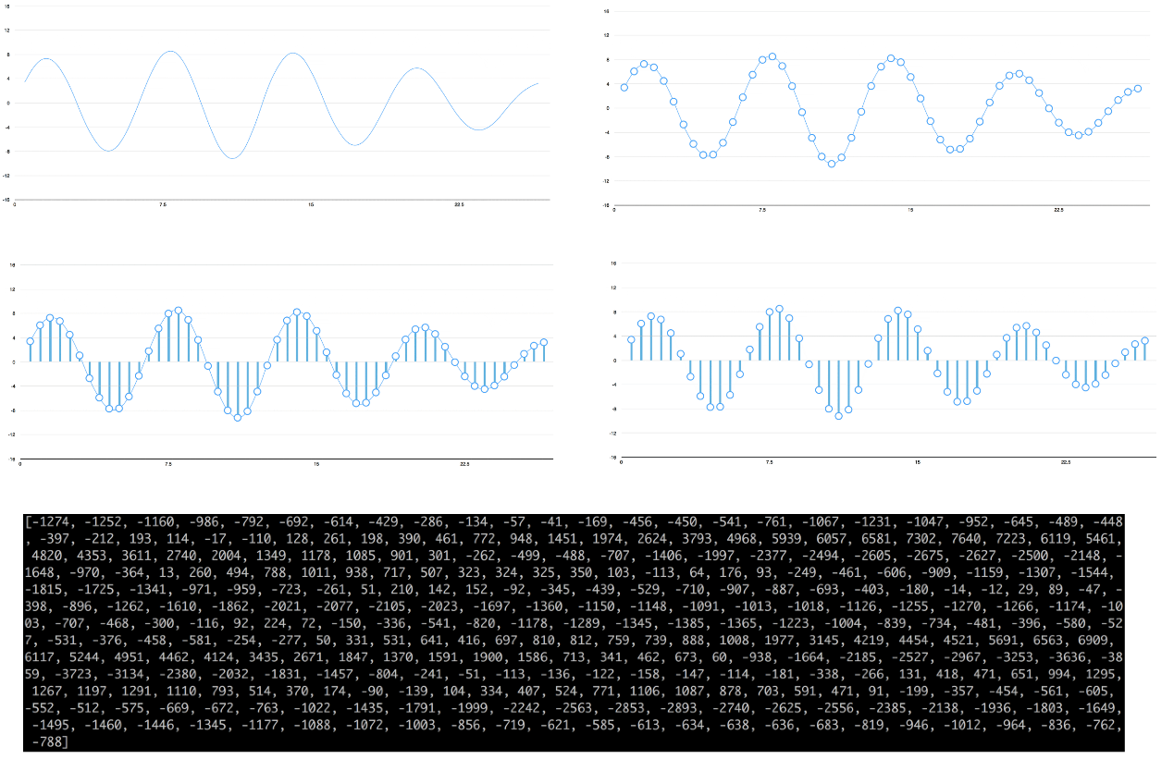

Figure 2.1 Sound sampling process [12].

## Mel Frequency Cepstral Coefficients

Mel Frequency Cepstral Coefficients (MFCC) is one of the most commonly used feature extraction method in speech recognition introduced by Davis and Mermelstein in the 1980's [13]. The technique is called FFT based which means that feature vectors are extracted from the frequency spectra of the windowed speech frames [9].

The common steps to do MFCC are framing and windowing, Discrete Fourier Transform (DFT) and power spectrum, mel filterbank, logarithm, and finally Discrete Cosine Transform (DCT) before feeding to convolutional neural network. [9, 13, 14, 15]. Yet there can be variations can be made in process [15].

### Framing and Windowing

A step can be done before framing and windowing is to apply a pre-emphasis filter on the signal to amplify the high frequencies. A pre-emphasis filter is useful in several ways such as, balance the frequency spectrum since high frequencies usually have smaller magnitudes compared to lower frequencies, avoid numerical problems during the Fourier transform operation, and may also improve the Signal-to-Noise Ratio [14]. The pre-emphasis filter can be applied to a signal $x$ using the first order filter in the following equation where typical values for the filter coefficient ($α$) are 0.95 or 0.97 [14]:

$$y\left(t\right)=x\left(t\right)-αx\left(t-1\right)$$

Framing is done because of an audio signal is constantly changing, so to simplify things, assuming that on short time scales the audio signal doesn't change. Typically, signal is framing into 20-40ms frames (25ms is standard). If the frame is much shorter, it doesn't have enough samples to get a reliable spectral estimate, if it is longer the signal changes too much throughout the frame [13]. Frame stripe typically is 10ms, which allows some overlap to the frames. If the speech file does not divide into an even number of frames, pad it with zeros so that it does [13]. This step is similar to pre-processing image in the convolutional neural network in the previous section.

After slicing the signal into frames, apply a window function such as the Hamming window to each frame can be done. Several reasons apply a window function to the frames, notably to counteract the assumption made by the FFT that the data is infinite and to reduce spectral leakage. Hamming window has the following form where, $0≤n≤N-1$, $N$ is the window length [14]:

$$w\left[n\right]=0.54-0.46\cos\left(\frac{2πn}{N-1}\right)$$

### Discrete Fourier Transform and Power Spectrum

Compute each window with Discrete Fourier Transform (DFT) or Fast Fourier Transform (FFT) can be followed with compute power spectrum (periodogram). Motivated by the human cochlea which vibrates at different spots depending on the frequency of the incoming sounds. The periodogram estimate performs a similar job, identifying which frequencies are present in the frame [13]. Periodogram use the following equation where, $x_{i}$ is the $i^{th}$ frame of signal $x$ and $N$ is FFT size as a power of two greater than or equal to the number of samples in a single window length [14]:

$$P=\frac{{\left|FFT\left(x_{i}\right)\right|}^{2}}{N}$$

### Mel Filterbank

The periodogram spectral estimate still contains a lot of information not required for speech recognition. In particular the cochlea cannot discern the difference between two closely spaced frequencies. This effect becomes more pronounced as the frequencies increase. For this reason, take clumps of periodogram bins and sum them up to get an idea of how much energy exists in various frequency regions. This is performed by mel filterbank [13].

Computing mel filterbank is applying triangular filters, typically 20 – 40 (26 or 40 is standard) filters, on a mel-scale to the power spectrum to extract frequency bands. Mel-scale aims to mimic the non-linear human ear perception of sound, by being more discriminative at lower frequencies and less discriminative at higher frequencies. The formula to convert between Hertz ($f$) and Mel ($m$) using the following equations [14]:

$m=2595 \log_{10}\left(1+\frac{f}{700}\right)$ $f=700\left({10}^{\frac{m}{2595}}-1\right)$

Each filter in the filterbank is triangular having a response of 1 at the center frequency and decrease linearly towards 0 till it reaches the center frequencies of the two adjacent filters where the response is 0 [14]. Good values are to start filter from 300Hz for the lower and up to 8000Hz for the upper frequency [13]. The filterbank can be modelled by the following equation [14]:

$$H_{m}\left(k\right)=\left\{\begin{aligned}0, &k<f(m-1) \\ \frac{k-f\left(m-1\right)}{f\left(m\right)-f\left(m-1\right)}, &f(m-1)≤k<f(m) \\ 1, &k=f(m) \\ \frac{f\left(m+1\right)-k}{f\left(m+1\right)-f\left(m\right)}, &f(m)<k≤f(m+1) \\ 0, &k>f(m+1)\end{aligned}\right.$$

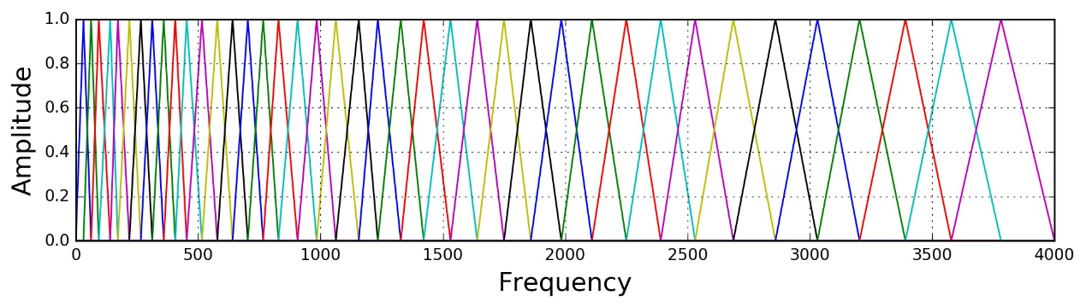

Figure 2.2 40 Filterbank from 0 Hz to 4000 [14].

### Logarithm

Once compute the mel filterbank, the next is simply take the logarithm of them. This is also motivated by human hearing, as humans don't hear loudness on a linear scale. Generally, to double the perceived volume of a sound it needs to put 8 times as much energy into it. This means that large variations in energy may not sound all that different if the sound is loud to begin with. This compression operation makes the features match more closely what humans actually hear [14].

### Discrete Cosine Transform

The final step is to compute the Discrete Cosine Transform (DCT). There are 2 main reasons this is performed. It because the filterbanks are all overlapping and the filterbank energies are quite correlated with each other. The DCT decorrelates the energies which means diagonal covariance matrices can be used to model the features. But only 12 of the DCT coefficients are kept. This is because the higher DCT coefficients represent fast changes in the filterbank energies and it turns out that these fast changes actually degrade speech recognition performance, so dropping them will get a small improvement [13].

## Machine Learning

Machine learning is a form of AI that enables a system to learn from data rather than through explicit programming [16]. Others state that machine learning usually refers to the changes in systems that perform tasks associated with artificial intelligence (AI) [17].

In general, there are 2 types of machine learning, Supervised Learning and Unsupervised Learning [16, 17, 18].

### Supervised Learning

In supervised learning, the algorithms are trained using pre-processed examples, and at this point, the performance of the algorithms is evaluated with test data. Occasionally, patterns that are identified in a subset of the data can’t be detected in the larger population of data. If the model is fit to only represent the patterns that exist in the training subset, it creates a problem called overfitting [16].

Overfitting means that the machine learning model is precisely tuned for the training data but may not be applicable for large sets of unknown data. To protect against overfitting, testing needs to be done against unforeseen or unknown labelled data. Using unforeseen data for the test set can help evaluate the accuracy of the model in predicting outcomes and results [16].

### Unsupervised Learning

In unsupervised learning, the algorithms segment data into groups of examples (clusters) or groups of features. The unlabelled data creates the parameter values and classification of the data. In essence, this process adds labels to the data so that it becomes supervised [16].

Unsupervised learning can determine the outcome when there is a massive amount of data. Unsupervised can be used as the first step before passing the data to a supervised learning process if one doesn’t know the context of the data being analysed, and labelling isn’t possible at the stage [16].

## Neural Network

A neural network is an approach to machine learning in which small computational units are connected in a way that is inspired by connections in the brain [18]. Non-linear elements have as their inputs a weighted sum of the outputs of other elements, much like networks of biological neurons do [17].

Every neural network model is basically a three-layered system, which are Input layer, Hidden Layer and Output Layer [16, 18]. Input layer, is designed to receive information from the outside model. While the other side of the network, an output layer, communicates a decision about the data that has been received. Between these, other layers communicate information about elements of the input to each other, which contribute to the output [18].

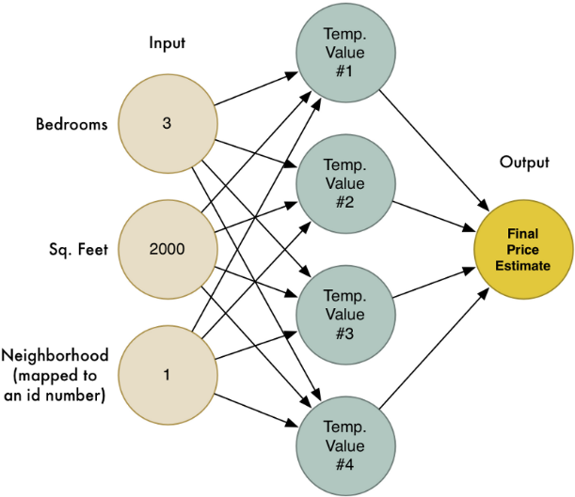

Figure 2.3 Neural network to find estimated price from specific input [19].

## Convolutional Neural Network

Convolutional neural network (CNN or ConvNet) is one of known variants neural network model to recognized image [20]. As an image is just an image is really just a grid of numbers that represent how dark each pixel to a computer [19].

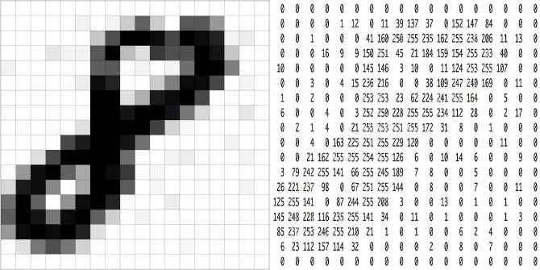

Figure 2.4 Computer read an image [19].

The model is designed to recognize an object no matter what surface the object is on. The model doesn’t have to re-learn the idea of child for every possible surface it could appear on [19].

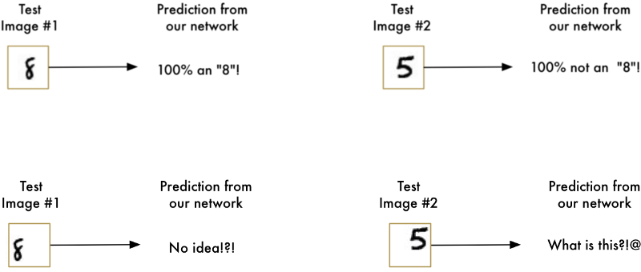

Figure 2.5 The basic neural network where it only recognizes the object on the center (top), but doesn't on another surface (bottom) [19].

The steps to applied convolutional neural network is the combination of convolution, max-pooling, and fully-connected layers. And yet, it might need a lot of experimentation and testing. Training a lot of model before find the optimal structure and parameters to solve the problem [19].

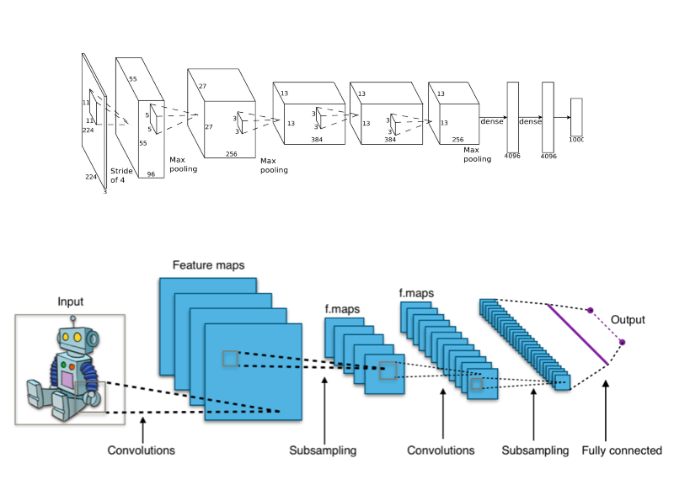

Figure 2.6 Before (left) and after (right) pre-processing image [19, 20].

### Pre-processing

Pre-processing is the preparation process by breaking the image into overlapping image tiles so that it can be feed into the model. Sliding window over the entire image will break the image into overlapping image tiles resulting equally sized tiny image tiles [19].

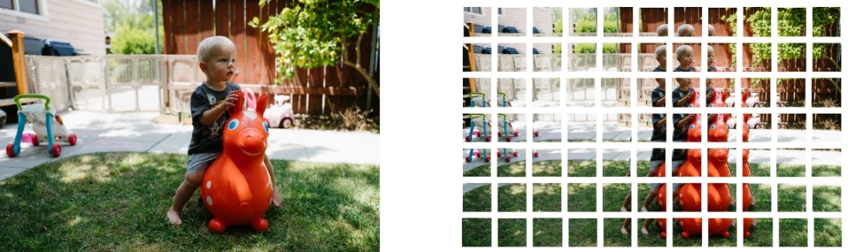

Figure 2.7 Before (left) and after (right) pre-processing image [19].

### Convolution Layer

Convolution layer is the layer to feed the pre-processing image or another output into small neural network. The small neural network treating every image or output equally. It will mark if something interesting appears as the model learning [19].

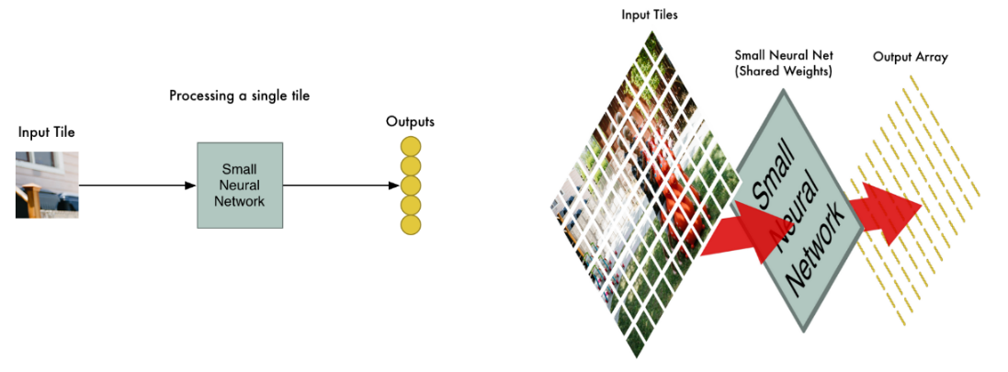

Figure 2.8 Convolution process on single tile (top) and overview all tiles (bottom) [19].

### Max-pooling Layer

Max-pooling or down sampling is the layer to reducing the output by finding maximum value in the output. The process is similar like pre-processing in the previous section. The output broke down into equal pool size and stride or slide into entire output. Then, each pool is found the maximum value [19].

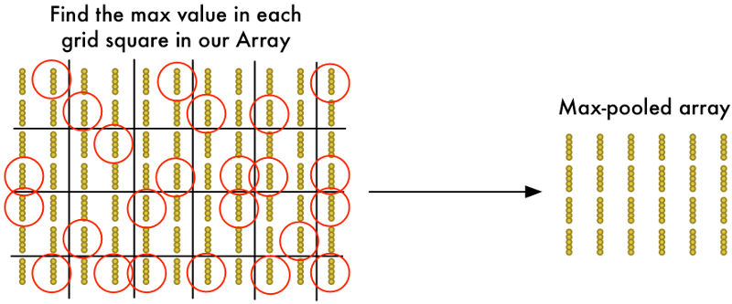

Figure 2.9 Max-pooling layer with 2x2 pool size and 2 strides [19].

### Fully-connected Layer

Fully-connected is the layer to high-level reasoning in the dense neural network to recognize the image [20].

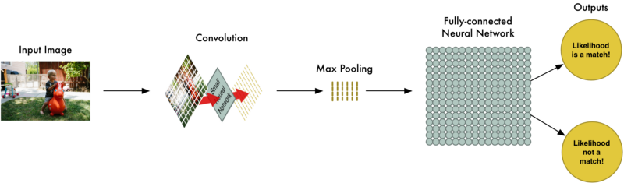

Figure 2.10 Fully-connected layer in CNN [19].

## Related Work

The following are most related work to the research. Have relation to mimic speech, both speech recognition and speech synthesis.

### Lyrebird

Lyrebird is website application, *https://lyrebird.ai*, that has 3 products: Custom Voice, Vocal Avatar, and Vocal Avatar API. Custom voice is a product to create speech based on real people’s speech, it can control the intonation, expression, and the emotion of the speech. Vocal avatar is a product to create own digital speech by read some English sentences, and then generate any sentences with own digital speech. Vocal avatar API is a product to provide API to use user’s own vocal avatar [21].

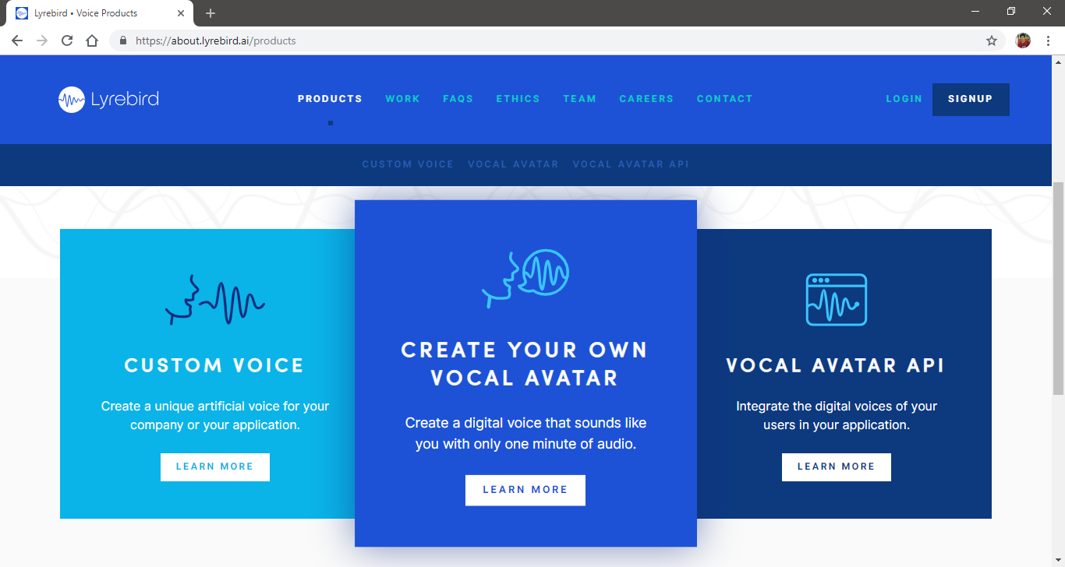

Figure 2.5 Screenshot of Lyrebird in the website [21].

### Google Translate

Google Translate is one of Google products that is an application to translate languages. Google Translate can be access freely through [*https://translate.google.com/*](https://translate.google.com/). It has many features and one of them is Talk feature. Talk has function to input text from speech and generate speech from text in any languages [22].

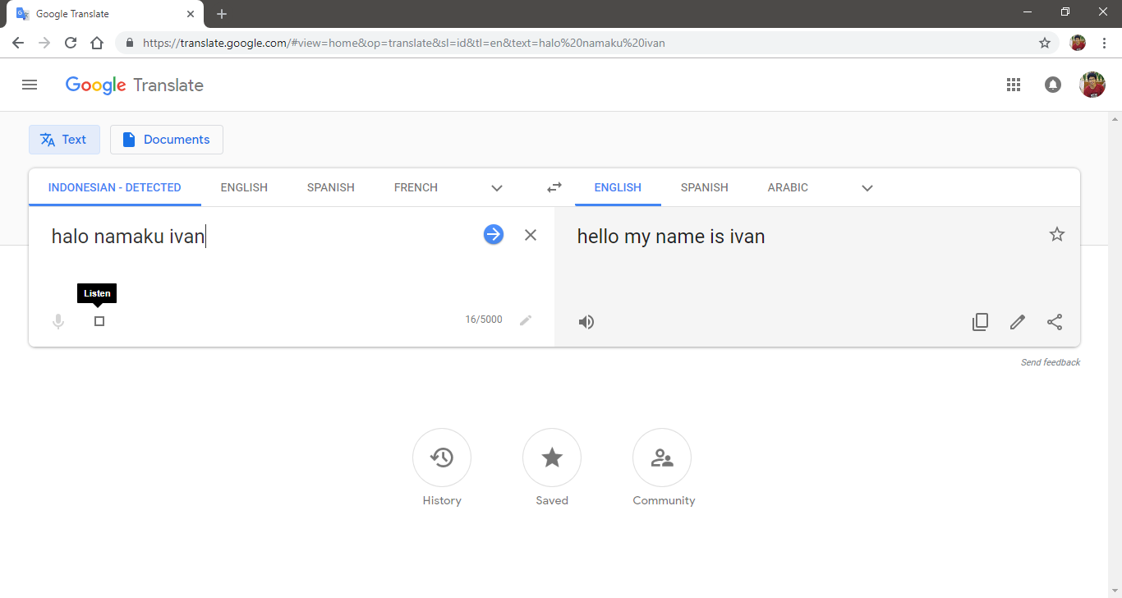

Figure 2.12 Screenshot of Google Translate in website [22].

From related work, it can be concluded that Lyrebird can mimic speech with its vocal avatar, but the speech is in English. In the other hand, Google Translate could mimic speech into any languages, but the speech vocal is from the Google Translate itself.

# SYSTEM ANALYSIS

## System Overview

This research is intended to implement speech recognition and speech synthesis into this research. This research consists of 3 application, Collect, Train, and Mimic application. Collect application is used to collect speech data. Train application train model with collected data for speech recognition with convolutional neural network as machine learning model. Mimic application is used to mimic the speech. It identifies what user said with trained model. Saves the speech data if the model recognizes. Then, it generates speech with concatenating saved speech data. Collect application and Mimic application develops in website application.

## Functional Analysis

There are several functions for each application listed in the Table 3.1 up to 3.3.

Table 3.1 Collect application functionality table.

|  |  |
| --- | --- |
| **No** | **Function Description** |
| 1 | Allow user to access Collect application. |
| 2 | Allow user to record user’s speech. |

Table 3.2 Train application functionality table.

|  |  |
| --- | --- |
| **No** | **Function Description** |
| 1 | Allow user to train model with collected data. |

Table 3.3 Mimic application functionality table.

|  |  |
| --- | --- |
| **No** | **Function Description** |
| 1 | Allow user to access Mimic application |
| 2 | Allow user to identify user’s speech. |
| 3 | Allow user to generate speech. |

## Software and System Requirements

This research and application development should be supported by the following list requirement in order to write the research, build and run the application well.

1. Laptop / Personal Computer

Laptop or Personal Computer is used as the tool where operating system is run. In this research, ASUS A455LN is used with Windows 10 as the OS.

1. Browser

Browser is used as development tool when developing website application. In this research, Chrome v70.0.3538.110 is used.

1. Microsoft Office Word

Microsoft Office Word is used to write the research documentation. In this research, Microsoft Office Word 2016 is used.

1. Node.js, JavaScript Run-Time Environment.

Node.js is an open source server environment – Node.js is free – Node.js runs on various platform (Windows, Linux, Unix, Mac OS X, etc) – Node.js uses JavaScript on the server [23]. In this research, Node.js v10.14.1 is used.

1. NoSQL document-oriented database

Document databases pair each key with a complex data structure known as a document. Documents can contain many different key-value pairs, or key-array pairs, or even nested documents [24]. In this research, MongoDB Community Server 4.0.2 as database server and MongoDB Compass 1.15.4 as MongoDB UI.

1. Integrated Development Environment (IDE)

IDE is used as application development environment. In this research, Visual Studio Code 1.30.0 is used.

1. Git

Git is used as version control. The repository is placed on local and cloud as preventive action. In this research, Git 2.18.0.windows.1 and GitLab as cloud repository is used.

## System Architecture

The system architecture explains about the use-case diagram and narrative for this application in both point of view, the actors and the system.

### Use-Case Diagram

Use-Case Diagram defines the functionality of a system and explains it in user point of view. The actors in this research is the application user. The diagram is shown in Figure 3.1.

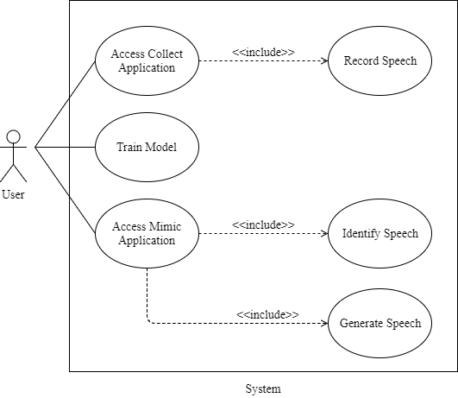

Figure 3.1 Use-case diagram.

### Use-Case Narrative

Use-Case Narrative explains the interaction between the actors and the system. It describes the detail of use-cases such as name, description, pre-condition, post-condition, business rules, and the course of events that happened in the system. The Use-Case Narrative is shown in Table 3.4 up to Table 3.9.

Table 3.4 Use-case narrative – Access Collect application.

|  |  |  |
| --- | --- | --- |
| **User Case Name** | **Access Collect application** | |
| Use Case ID | UC01 | |
| Priority | High | |
| Primary Business Actor | User | |
| Primary System Actor | System | |
| Another Participating Actor | None | |
| Description | This use-case describes the event when user opens Collect application through browser. | |
| Precondition | None | |
| Trigger | User opens Collect application. | |
| Typical Course of Event | **Actor Action** | **System Response** |
| Click Start button. | Syllables page is shown. |
| Alternate Course | None | |
| Post Condition | Home page is shown. | |
| Business Rule | None | |
| Implementation Constraint and Specifications | None | |

Table 3.5 Use-case narrative – Record speech.

|  |  |  |
| --- | --- | --- |
| **User Case Name** | **Record speech** | |
| Use Case ID | UC02 | |
| Priority | High | |
| Primary Business Actor | User | |
| Primary System Actor | System | |
| Another Participating Actor | None | |
| Description | This use-case describes the event when user opens Syllables page. | |
| Precondition | User clicks Start button from Home page. | |
| Trigger | User opens Syllables page. | |
| Typical Course of Event | **Actor Action** | **System Response** |
| Click Record button and say asked syllable. | Record the speech and upload to save it. |
| Alternate Course | **Actor Action** | **System Response** |
| Click Next button. | Next Syllables or Home page is shown. |
| Post Condition | Recorded speech is played on audio element. | |
| Business Rule | None | |
| Implementation Constraint and Specifications | None | |

Table 3.6 Use-case narrative – Train model.

|  |  |  |
| --- | --- | --- |
| **User Case Name** | **Train model** | |
| Use Case ID | UC03 | |
| Priority | High | |
| Primary Business Actor | User | |
| Primary System Actor | System | |
| Another Participating Actor | None | |
| Description | This use-case describes the event when user start Train application. | |
| Precondition | None | |
| Trigger | User starts Train application. | |
| Typical Course of Event | **Actor Action** | **System Response** |
|  | Load and extract collected data. |
|  | Split into train, validation, and test data. |
|  | Convert data to model’s input and output. |
|  | Train the model with train data and validate with validation data. |
|  | Test the model with test data and insert the model to MongoDB. |
| Alternate Course | None | |
| Post Condition | Model is trained and inserted in MongoDB. | |
| Business Rule | None. | |
| Implementation Constraint and Specifications | None | |

Table 3.7 Use-case narrative – Access Mimic application.

|  |  |  |
| --- | --- | --- |
| **User Case Name** | **Access Mimic application** | |
| Use Case ID | UC04 | |
| Priority | High | |
| Primary Business Actor | User | |
| Primary System Actor | System | |
| Another Participating Actor | None | |
| Description | This use-case describes the event when user opens Mimic application through browser. | |
| Precondition | None | |
| Trigger | User opens Mimic application. | |
| Typical Course of Event | **Actor Action** | **System Response** |
| Click Identify Speech or Generate Speech button. | Identify or Generate page is shown. |
| Alternate Course | None | |
| Post Condition | Home page is shown. | |
| Business Rule | None | |
| Implementation Constraint and Specifications | None | |

Table 3.8 Use-case narrative – Identify speech.

|  |  |  |
| --- | --- | --- |
| **User Case Name** | **Identify speech** | |
| Use Case ID | UC05 | |
| Priority | High | |
| Primary Business Actor | User | |
| Primary System Actor | System | |
| Another Participating Actor | None | |
| Description | This use-case describes the event when user opens Identify page. | |
| Precondition | User clicks Identify Speech button from Home page. | |
| Trigger | User opens Identify page. | |
| Typical Course of Event | **Actor Action** | **System Response** |
| Click Record button and say something. | Record the speech and upload to save it. |
|  | Recorded speech is played on audio element. |
| Insert speech ID in input element and click Identify Speech button. | Recorded speech is identified with trained model. |
|  | Speech data is updated to MongoDB if recognized. |
| Alternate Course | **Actor Action** | **System Response** |
| Click Finish button. | Home page is shown. |
| Post Condition | Information whether recognized or not is alerted in the browser. | |
| Business Rule | None | |
| Implementation Constraint and Specifications | None | |

Table 3.9 Use-case narrative – Generate speech.

|  |  |  |
| --- | --- | --- |
| **User Case Name** | **Identify speech** | |
| Use Case ID | UC06 | |
| Priority | High | |
| Primary Business Actor | User | |
| Primary System Actor | System | |
| Another Participating Actor | None | |
| Description | This use-case describes the event when user opens Generate page. | |
| Precondition | User clicks Generate Speech button from Home page. | |
| Trigger | User opens Generate page. | |
| Typical Course of Event | **Actor Action** | **System Response** |
|  | Load speech data from MongoDB. |
| Choose speech ID from datalist element. | Speech ID selected. |
| Insert text in input element and click Generate Speech button. | Speech is generated based selected speech ID and inserted text. |
| Alternate Course | **Actor Action** | **System Response** |
| Click Finish button. | Home page is shown. |
| Post Condition | Generated speech is played on audio element. | |
| Business Rule | None | |
| Implementation Constraint and Specifications | None | |

### Activity Diagram

Activity Diagram presents a series of actions and flow of control in a system. The activity diagram is separated into each application.

#### Collect Application

This activity describes the Collect application which is start when user opens the application. Home page will be shown as the home page. As user clicks Start button, the Syllables page will be shown. User can record asked syllables by click Record button. Recorded speech is played in audio element. User can also change the next asked syllables by click Next button and the next Syllables page will be shown. If there are no more asked syllables, Home page will be shown instead the next Syllables page.

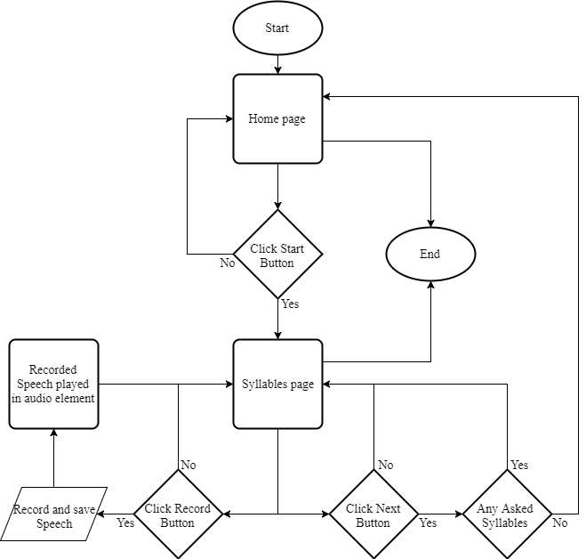

Figure 3.2 Collect application activity diagram.

#### Train Application

This activity describes the Train application which is start when user starts the application. Collected data will be loaded and extracted. Then, data split into train, validation, and test data. Each split data converted to model’s input and output. The model is trained with train data and validated with validation data. Finally, the model is tested with test data and inserted to MongoDB. The model is trained and ready to use by Mimic application.

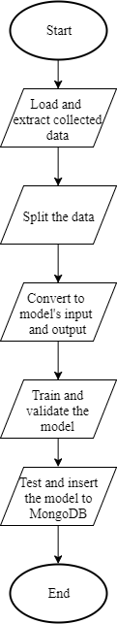

Figure 3.3 Train application activity diagram.

#### Mimic Application

This activity describes the Mimic application which is start when user opens the application. Home page will be shown as the home page. As user clicks Identify Speech button, the Identify page will be shown. User can record speech by click Record button. Then, user inserts speech ID on input element to name the speech data and click Identify Speech button to identify the recorded speech. Recognized speech will update the speech data to MongoDB. Any information regarding to identify process is alerted when finish to the browser. User can also click Finish button and Home page will be shown again. As user clicks Generate Speech button, the Generate page will be shown. Speech ID is loaded as shown as the page is loaded. User can choose speech ID. Inserts text on textarea element. And clicks Generate Speech button to generate speech based on the speech ID and the text. Generated speech is played in audio element. There’s also Finish button in Generate page that also shown Home page when clicked.

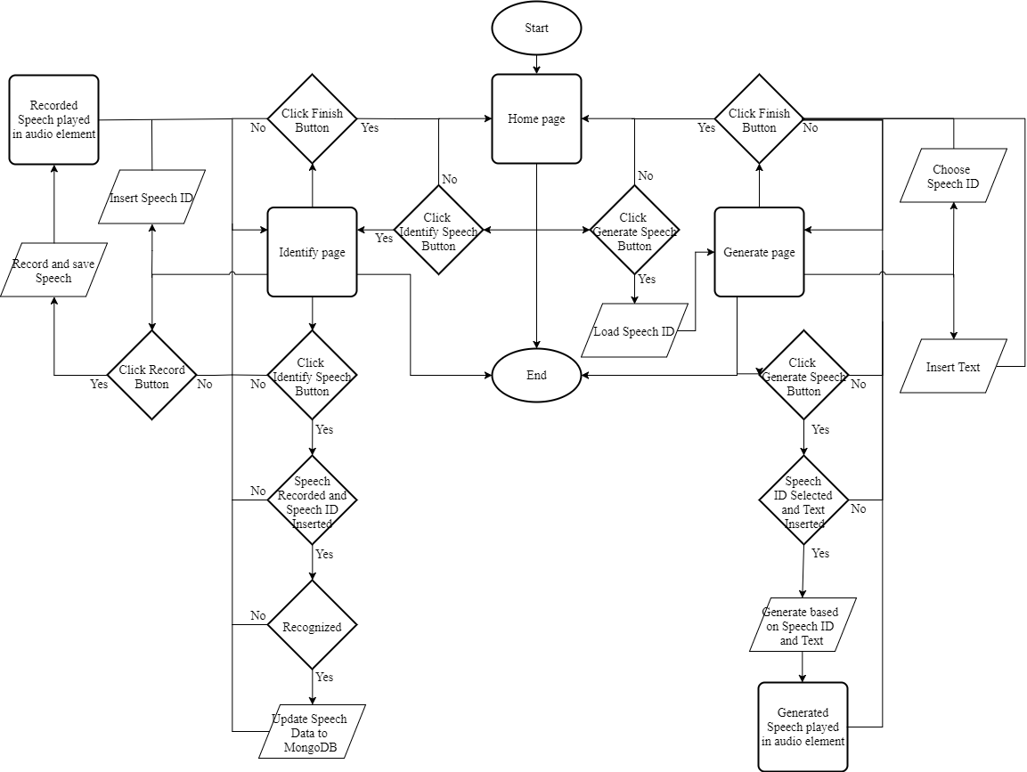

Figure 3.3 Mimic application activity diagram.

# SYSTEM DESIGN

## User Interface Design

The UI is applied on Collect and Mimic application. There are two core pages in Collect application and three core pages in Mimic Application.

### Collect Application

Two core pages in Collect application are Home page and Syllables page.

#### Home Page

Home page is the home page of the Collect application. When user opens the Collect application or directed from Mimic application or redirect back from Syllables page, it will show the Home page that consist of title, information regarding to Collect application, and 2 buttons such as Start and Mimic Home.



Figure 4.1 Collect Home page.

Table 4.1 Collect Home page description.

|  |  |
| --- | --- |
| **No** | **Description** |
| 1 | Title |
| 2 | Information |
| 3 | Start Button |
| 4 | Mimic Home Button |

#### Syllables Page

Syllables page is the main page of the Collect application. When user click Start in the Home page, it will show the Syllables page that consist of title regarding to which syllables should be recorded, audio element, and 2 buttons such as Record and Next.

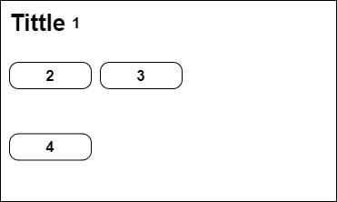

Figure 4.2 Collect Syllables page.

Table 4.2 Collect Syllables page description.

|  |  |
| --- | --- |
| **No** | **Description** |
| 1 | Title |
| 2 | Audio Element |
| 3 | Record Button |
| 4 | Next Button |

### Mimic Application

Three core pages in Mimic application are Home page, Identify page, and Generate page.

#### Home Page

Home page is the home page of the Mimic application. When user opens the Mimic application or directed from Collect application or redirect back from Identify or Generate page, it will show the Home page that consist of title, information regarding to Mimic application, and 3 buttons such as Identify Speech, Generate Speech and Collect Home. The description of the design layout is shown in Table 4.3.



Figure 4.3 Mimic Home page.

Table 4.3 Mimic Home page description.

|  |  |
| --- | --- |
| **No** | **Description** |
| 1 | Title |
| 2 | Information |
| 3 | Identify Speech Button |
| 4 | Generate Speech Button |
| 5 | Collect Home Button |

#### Identify Page

Identify page is the one of the main pages of the Mimic application. When user click Identify Speech in the Home page, it will show the Identify page that consist of title, information registered syllables, 2 elements such as input and audio, and 3 buttons such as Record, Identify Speech, and Finish.

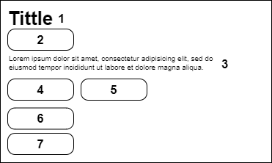

Figure 4.4 Mimic Identify page.

Table 4.4 Mimic Identify page description.

|  |  |
| --- | --- |
| **No** | **Description** |
| 1 | Title |
| 2 | Input Element |
| 3 | Information |
| 4 | Audio Element |
| 5 | Record Button |
| 6 | Identify Button |
| 7 | Finish Button |

#### Generate Page

Generate page is the other main pages of the Mimic application. When user click Generate Speech in the Home page, it will show the Generate page that consist of title, 3 elements such as datalist, textarea, and audio, and 2 buttons such as Generate Speech, and Finish.

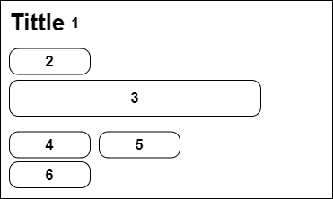

Figure 4.5 Mimic Generate page.

Table 4.5 Mimic Generate page description.

|  |  |
| --- | --- |
| **No** | **Description** |
| 1 | Title |
| 2 | Datalist Element |
| 3 | Textarea Element |
| 4 | Audio Element |
| 5 | Generate Button |
| 6 | Finish Button |

## Class Diagram

The class diagram is the structure of the system used toward this research. The class diagram in this research consist of Collect, Train, and Mimic application, server that handle Collect and Mimic application, and database that handle connection to MongoDB.

### Collect Application

The core classes in the Collect application are home and syllables. They are the front-end of Collect application.

#### home

home is HTML that render the Home page. It consists html tags based on the UI design on the previous section and JavaScript to handle the buttons.

#### syllables

syllables is HTML that render the Syllables page. It consists html tags based on the UI design on the previous section, JavaScript to handle the buttons, and JavaScript to handle the record that will be uploaded.

The upload handler contains file, randomString, and XMLHttpRequest methods. file is used to create wav blob from the record. randomString is used to randomize string for naming the record file and reducing duplicate that will overwrite one file to another. XMLHttpRequest is used to send upload request to the server and receive response from the server.

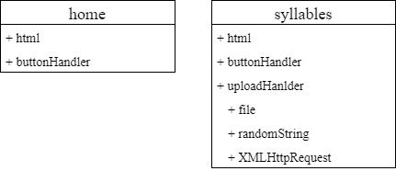

Figure 4.6 Collect application class diagram.

### Train Application

The core classes in the Train application are model and train. They are the code to train the machine learning model with collected data.

#### model

model is JavaScript that define model to be Convolutional Neural Network model that will be used by train. It contains add method. add is used to add layer to the model.

#### train

train is JavaScript that setup and train the model based on model. It contains loadData, nextBatch, saveModelDB, fit, and test methods. loadData is used to load collected data from Collect application, split to train, validation, and test data, and extract all of them. nextBatch is used to get portion of loadData result and convert it to model input output. saveModelDB is used to insert the model to MongoDB. fit is used to train the model with train data and validate with validate data. test is used to test the model with test data.

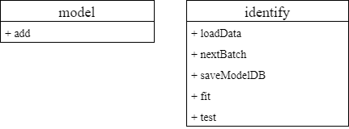

Figure 4.7 Train application class diagram.

### Mimic Application

The core classes in the Mimic application are home, identify, and generate. They are the front-end of Mimic application.

#### home

home is HTML that render the Home page. It consists html tags based on the UI design on the previous section and JavaScript to handle the buttons.

#### identify

identify is HTML that render the Identify page. It consists html tags based on the UI design on the previous section, JavaScript to handle the elements and buttons, JavaScript to handle the record that will be uploaded, and JavaScript to handle the record that will be identified.

The upload handler contains file, randomString, and XMLHttpRequest methods. file is used to create wav blob from the record. randomString is used to randomize string for naming the record file and reducing duplicate that will overwrite one file to another. XMLHttpRequest is used to send upload request to the server and receive response from the server.

The identify handler contains XMLHttpRequest methods. XMLHttpRequest is used to send identify request to the server and receive response from the server.

#### generate

generate is HTML that render the Generate page. It consists html tags based on the UI design on the previous section, JavaScript to handle the elements and buttons, JavaScript to handle the speech data that will be loaded from database, and JavaScript to handle the speech ID and text that will be generated to audio.

The load handler contains XMLHttpRequest methods. XMLHttpRequest is used to send load request to the server and receive response from the server.

The generate handler contains XMLHttpRequest methods. XMLHttpRequest is used to send generate request to the server and receive response from the server.

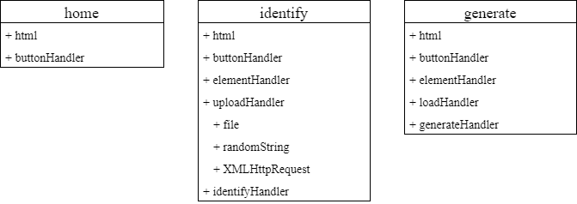

Figure 4.8 Mimic application class diagram.

### Server

The core classes in the server are serverHandler and createServer. They are the back-end of Collect and Mimic application.

#### serverHandler

serverHandler is JavaScript that define server listener that will be used by createServer. It consists of JavaScript to handle upload from Collect application, JavaScript to handle upload and identify from Mimic Identify page, JavaScript to handle load and generate from Mimic Generate page, and JavaScript to handle URL that will display and load in the browser.

The collect handler contains router and upload methods. router is used to check whether the request is point to collect handler or not. If yes, then upload will be executed. upload is used to upload file based on the request. Then, convert its upload path location to URL. It returns the URL as response.

The identify handler contains router, upload, and identify methods. router is used to check whether the request is point to identify handler or not. If yes, then upload or identify will be executed. upload is used to upload recorded file based on the request, then convert its upload path location to URL. It returns the URL and upload path as response. identify is used to identify the recorded file based on the request. It loads the latest trained machine learning model from database. Then, the extract result is test with the model. If the test result show high accuracy the file path is inserted to MongoDB based on the speech ID in the request and the identify result. It returns the information whether the model can identify or not as response.

The generate handler contains router, load, and generate methods. router is used to check whether the request is point to generate handler or not. If yes, then load or generate will be executed. load is used to load all the speech ID from speech data in the MongoDB. It returns the result as response. generate is used to generate speech based on text from the request. It loads the speech data from speech ID based on the request. Then, the text is check with the loaded speech data. If unmatched is found, it returns error as response. If all matched, the speech data corresponding to text is combined to 1 audio file. Finally, the file path is converted to URL and returns the result as response

#### createServer

createServer is JavaScript that create the server. It contains listen method. listen is used to listen any request that comes to the server. The request will be proceeded to serverHandler.

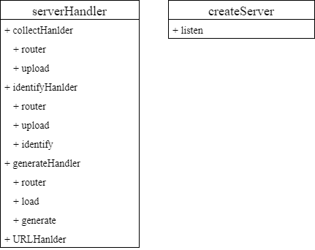

Figure 4.9 Server class diagram.

### Database

The core classes in the database are connection and model. They are the code that create connection to MongoDB and collection model scheme of the database on MongoDB.

#### connection

connection is JavaScript that handle the connection with MongoDB. It contains connect and disconnect methods. connect is used to establish the connection to MongoDB. disconnect is used to close the established connection.

#### model

model is JavaScript that create the collection model scheme of the database on MongoDB. It contains speechDatas and models schemes. speechDatas is used to define model for speech data collection scheme that is used on Mimic application. Each collection record speech ID and syllables. models is used to define model for machine learning model collection scheme that is used on Train and Mimic application. Each collection record model’s path and the date the model is saved.

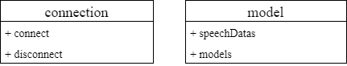

Figure 4.10 Database class diagram.

# SYSTEM DEVELOPMENT

## User Interface Development

The UI is applied on Collect and Mimic application. There are two core pages in Collect application and three core pages in Mimic Application.

### Collect Application

Two core pages in Collect application are Home page and Syllables page.

#### Home Page

Home page is the home page of the Collect application. It shows information about how the collecting process works and information regarding to the collecting process. There are also 2 buttons, Start and Mimic Home button.

Start button will direct user to Syllables page to start collecting. Mimic Home button will direct user to Mimic application Home page.

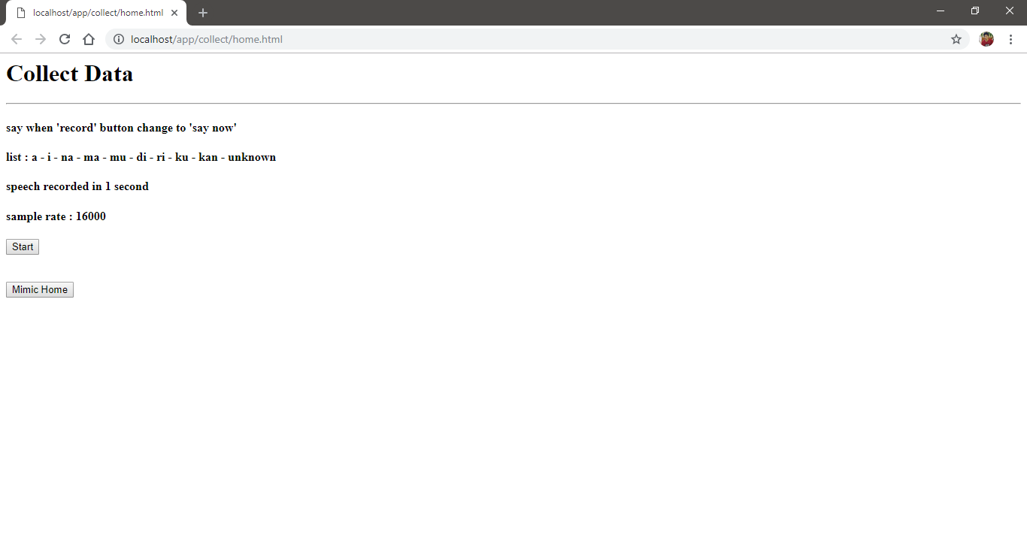

Figure 5.1 Collect Home page.

#### Syllables Page

Syllables page is the main page of the Collect application. It shows information about which syllable should be recorded and replayed the record. There are also 2 buttons, Record and Next button and an audio element. Any response from the server is also printed in the console.

Record button will start the record process. When the record process is starting, Record button will be renamed to ‘Say Now’ which tell user that the record process is starting and indicate user to say the relevant syllable. When the record process is finish, the recorded blob is uploaded to the server and Record button will be renamed to ‘Record Again’ which tell user that the record process is finish and user can do the next record. Next button will direct user to the next Syllables page. In this application there are 9 Syllables and 1 unknown Syllable. On the last syllables, Next button will direct user back to Home page.

Audio element will be shown when the record process is finish with an audio from the record. User can hear the replay of the record from the audio element.

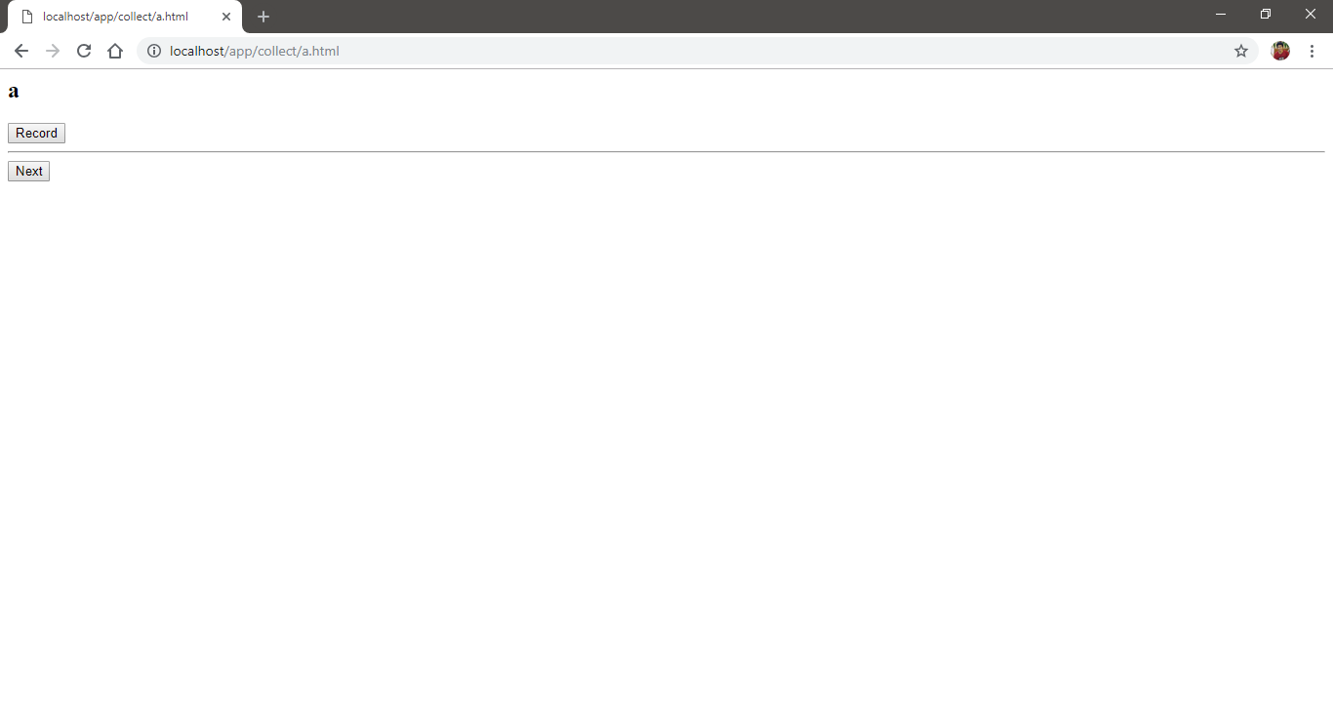

Figure 5.2 Collect Syllables page with ‘a’ syllable.

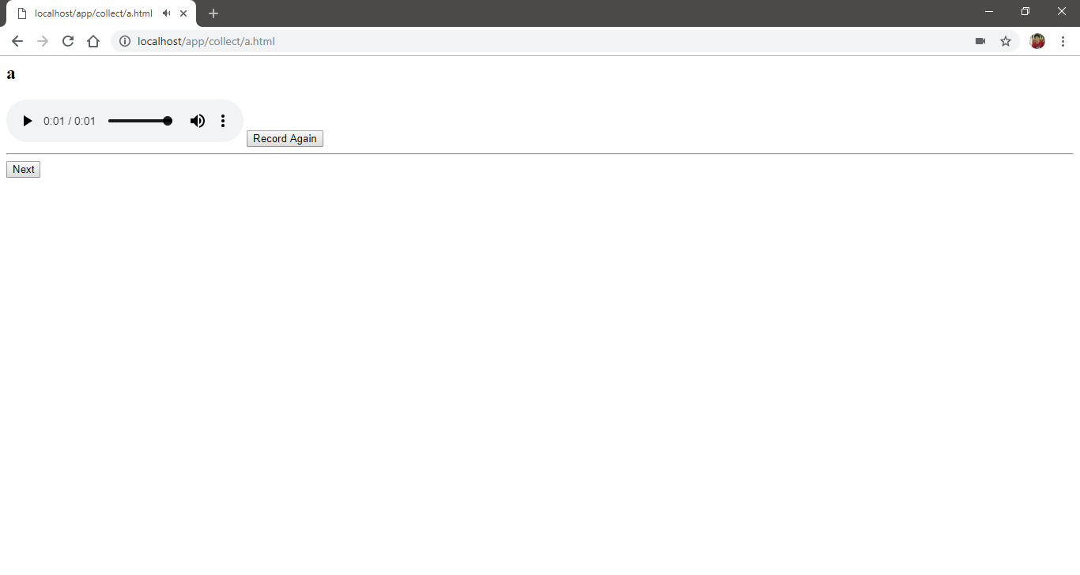

Figure 5.3 Collect Syllables page after record process is finish.

### Mimic Application

Three core pages in Mimic application are Home page, Identify page, and Generate page.

#### Home Page

Home page is the home page of the Mimic application. It shows information about how the mimic process works and information regarding to the identify and generate process. There are also 3 buttons, Identify, Generate, and Collect Home button.

Identify button will direct user to Identify page to start identifying speech. Generate button will direct user to Generate page to start generating speech. Collect Home button will direct user to Collect application Home page.

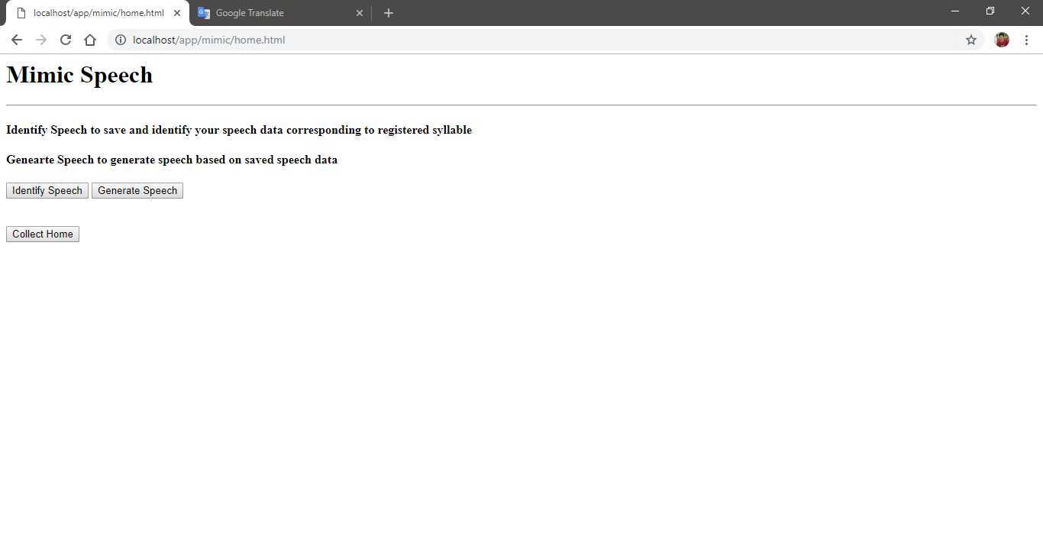

Figure 5.4 Mimic Home page.

#### Identify Page

Identify page is the one of the main pages of the Mimic application. It shows information about which syllable is recognizable and form of input and audio that will be used to identify the speech and update it to database. There are also 3 buttons, Record, Identify Speech and Finish button, and an input and an audio element. Any response from the server is also printed in the console.

Record button will start the record process. When the record process is starting, Record button will be renamed to ‘Say Now’ which tell user that the record process is starting and indicate user to say the syllable. When the record process is finish, the recorded blob is uploaded to the server Record button will be renamed to ‘Record Again’ which tell user that the record process is finish and user can do the next record. Identify Speech button will take the value of input element and file source of audio element, then, send them to the server to be identify. The indication of identify process in the server is success or error is there is alert on the browser that show any information regarding to identify process in the server. If there is no value of input element or file source of audio element, Identify Speech button will alert user that there is not any value. Finish button will direct user back to the Home page.

Audio element will be shown when the record process is finish with an audio from the record. User can hear the replay of the record from the audio element. Input element is used as input of user speech ID value.

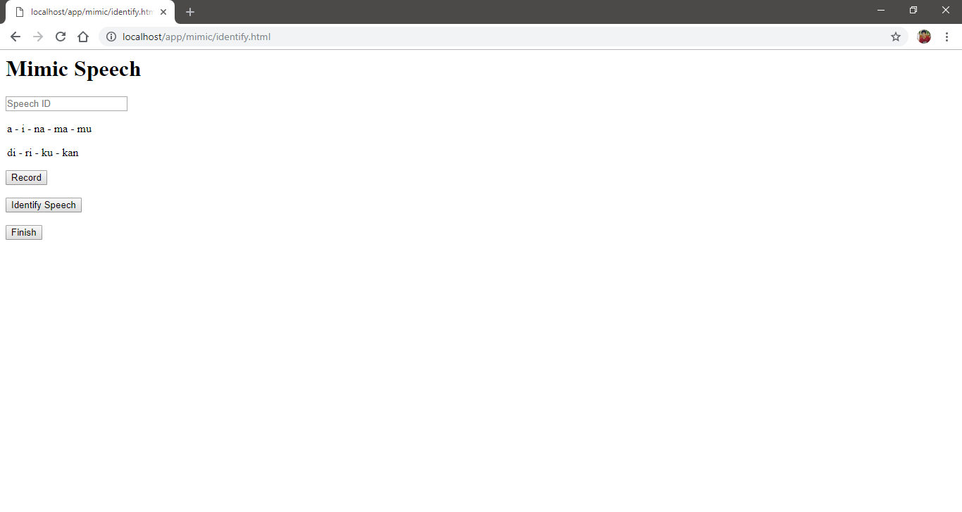

Figure 5.5 Mimic Identify page.

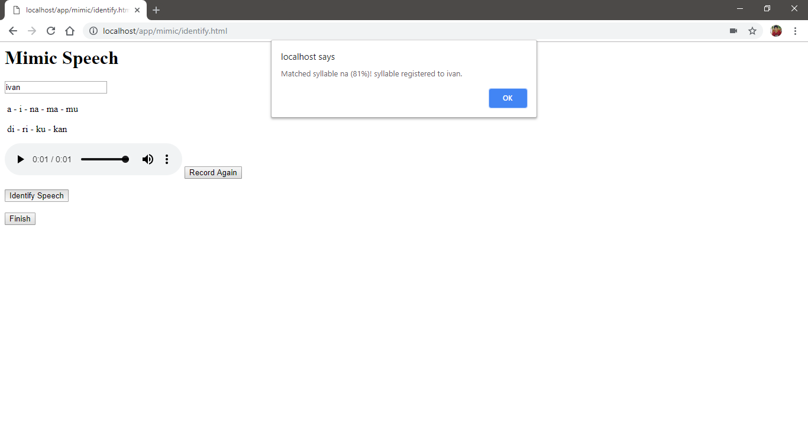

Figure 5.6 Mimic Identify page alert user indicating identify process in the server is finish.

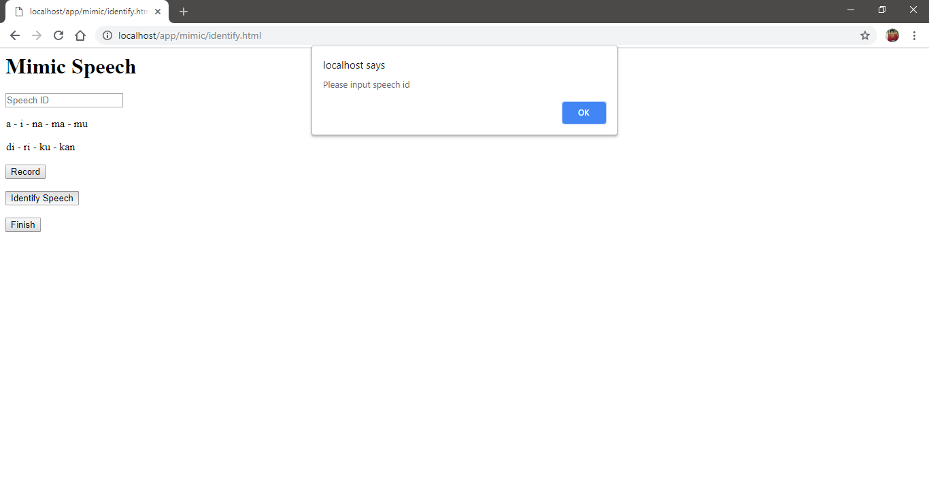

Figure 5.7 Mimic Identify page alert user indicating there is no value in input element.

#### Generate Page

Generate page is the one of the main pages of the Mimic application. It shows form of data list and text area that will be used to generate the speech. When the page is loading, it also loads speech data from the database and then store it on data list. If there is no speech data found, it will alert user and direct user back to Home page. There are also 2 buttons, Generate Speech and Finish button, and a datalist element, a textarea element and an audio element. Any response from the server is also printed in the console.

Generate Speech button will take the value of datalist element and textarea element, then, send them to the server to be generate. The indication of generate process in the server is error is there is alert on the browser that show any error information regarding to generate process in the server. The indication of generate process in the server is success is the audio element is shown with an audio from the generated speech. If there’s no value of datalist element or textarea element, Identify Speech button will alert user that there is not any value. Finish button will direct user back to the Home page.

Audio element will be shown when the generate process is success with an audio from the generated speech. User can hear the generated speech from the audio element. Datalist element is shows all speech data from database and it is used as input of user speech ID value. Textarea element is used as input of words that user want to generate.

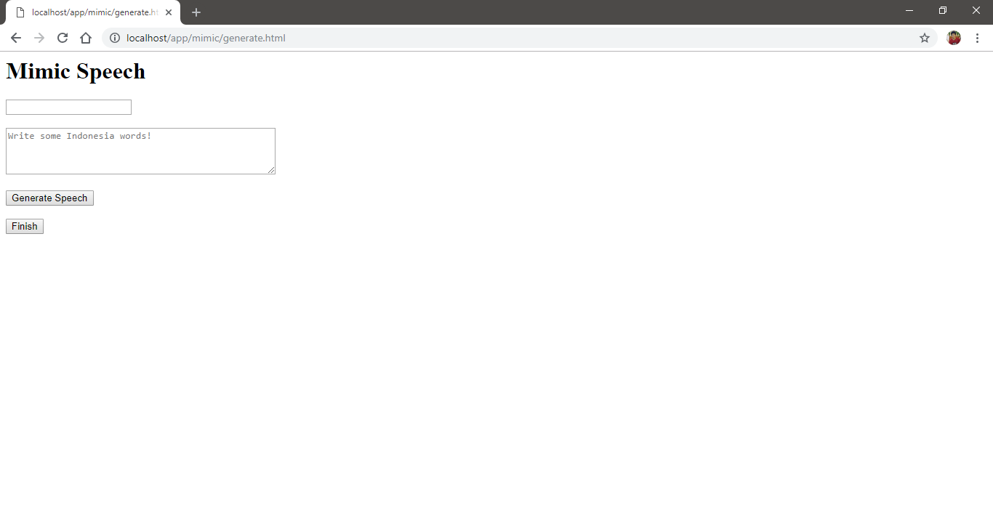

Figure 5.8 Mimic Generate page.

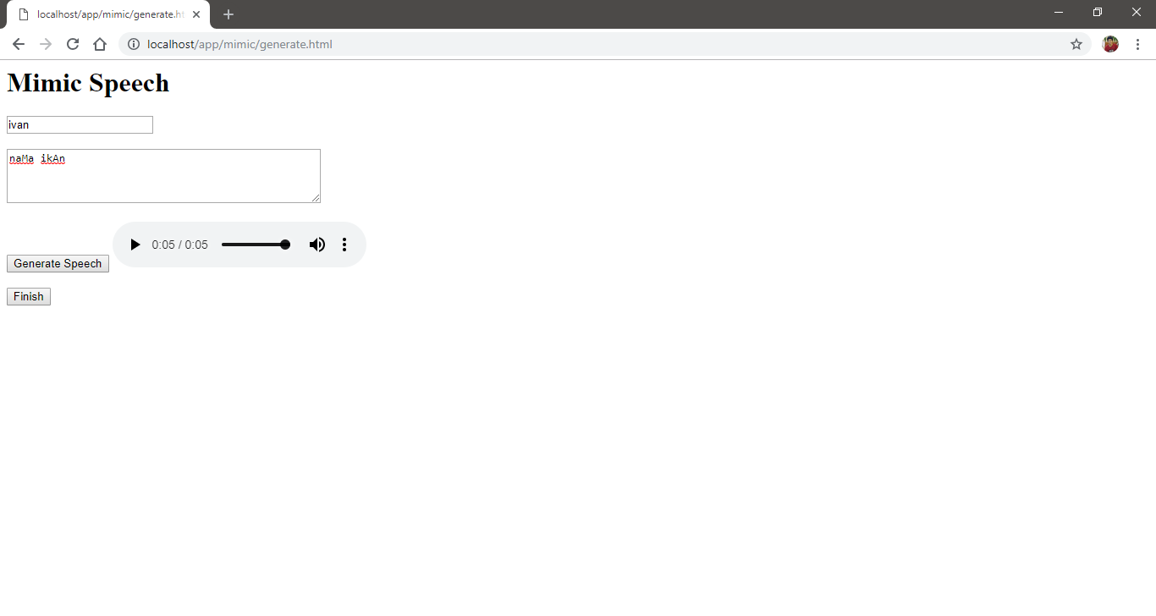

Figure 5.9 Mimic Generate page play the generated speech after generate process success.

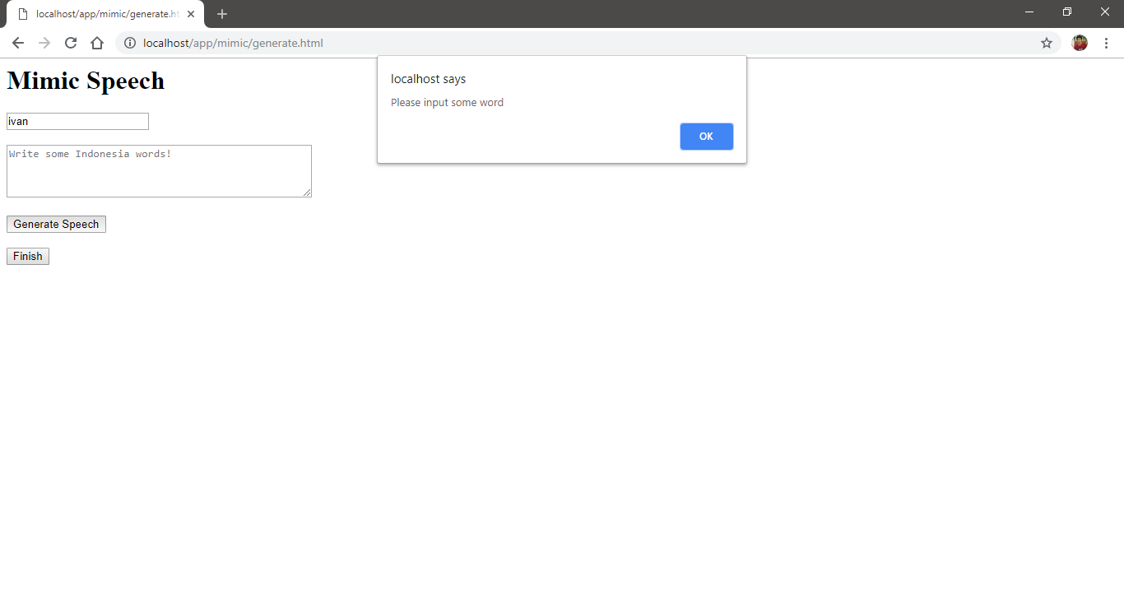

Figure 5.10 Mimic Generate page alert user indicating there is no value in textarea element.

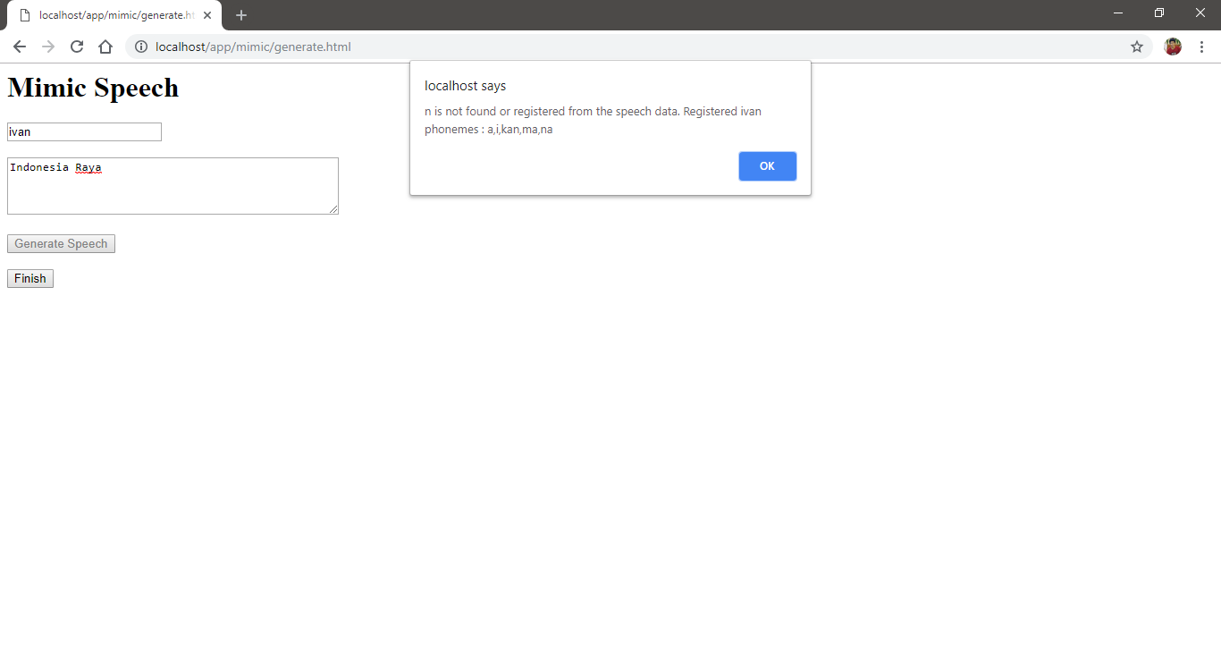

Figure 5.11 Mimic Generate page alert user indicating there is error in the generate process.

## Application Details

The application details explain some codes on Collect, Train, and Mimic application, server and database code based on previous chapter.

### Collect Application

Collect application code is used to create the front-end of Collect application. It consists of home and syllables.

#### home

home is used to render the Home page as shown in figure 5.1 and also handle the button in Home page. It is written on HTML and JavaScript.

home contains html, btnStart, and btnMimic. html is used to render Home page. btnStart is used to direct user to Syllables page. btnMimic is used to direct user to Mimic Home page.

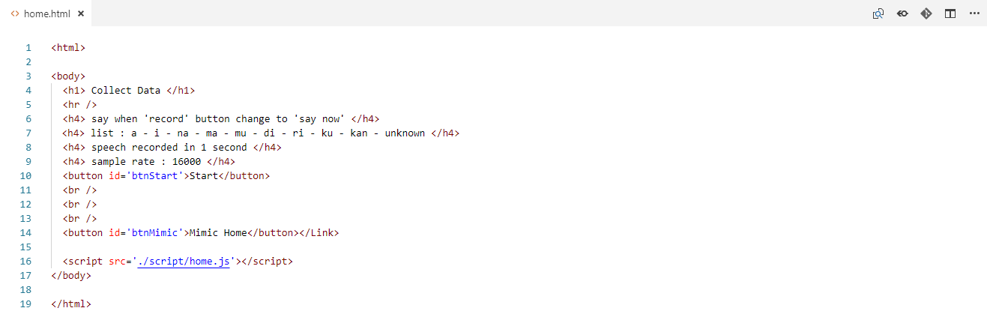

Figure 5.12 Collect home html code.

#### syllables

syllables is used to render the Syllables page as shown in figure 5.2 up to 5.3, handle the button in Syllables page, and also handle upload record. It is written on HTML and JavaScript. The upload handler, that contains file, randomString, and XMLHttpRequest, is forked from RecordRTC package. RecordRTC is a JavaScript-based media-recording library for modern web-browsers. It is optimized for different devices and browsers to bring all client-side recording solutions in single place [25].

syllables contains html, btnNext, btnRecord, captureUserMedia, postFiles, generateRandomString, and xhrPostUploadCollect. html is used to render Syllables page based on corresponding syllable. btnNext is used to direct user to the next Syllables page or redirect back to Home page if there is not any next syllable.

btnRecord is used to start record. It runs captureUserMedia first, that is used to ask user’s microphone permission. If the permission granted, it then starts recording for 1 seconds. After that it runs postFiles, that is used to store the wav blob from the record and generate random string for naming the file files from generateRandomString. Finally, xhrPostUploadCollect, that is used to send upload request based on corresponding syllable with the wav blob to the server and receive response from the server as the upload result, is run.

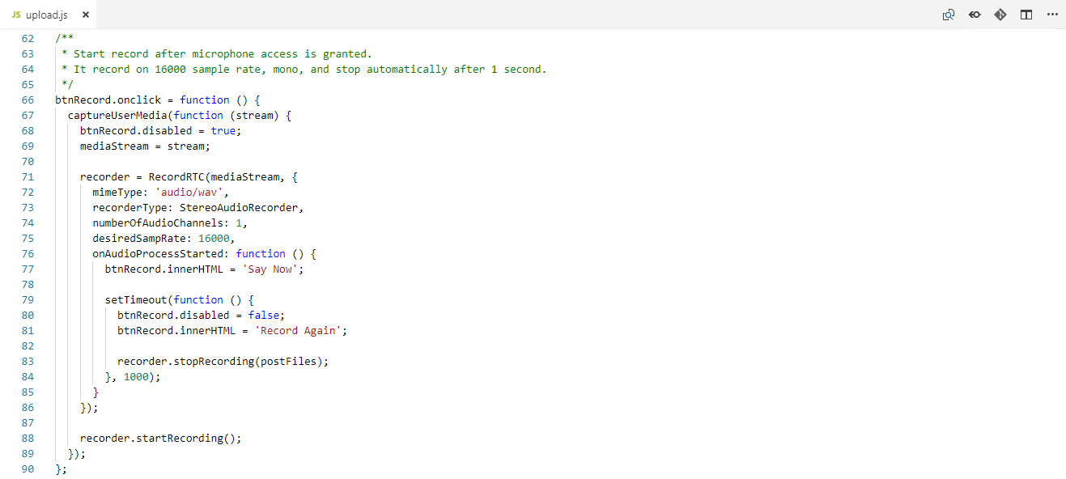

Figure 5.13 Collect syllables btnRecord code.

### Train Application

Train application code is used to train the machine learning model with collected data. It consists of model and train. It is develop using TensorFlow.js. TensorFlow is a JavaScript library for training and deploying ML models in the browser and on Node.js [26].

#### model

model is used to define model to be Convolutional Neural Network model that will be used by train. It is written on JavaScript. The model is inspired from TensorFlow speech_commands [27] and forked from TensorFlow.js speech_commands [28].

model contains modelML. modelML is used to contain defining process. As TensorFlow.js imported, use sequential to define model as a stack like. After that, add layer by simply use add and followed by the name of the layer. Finally, use compile to configures and prepares the model for training and evaluation.

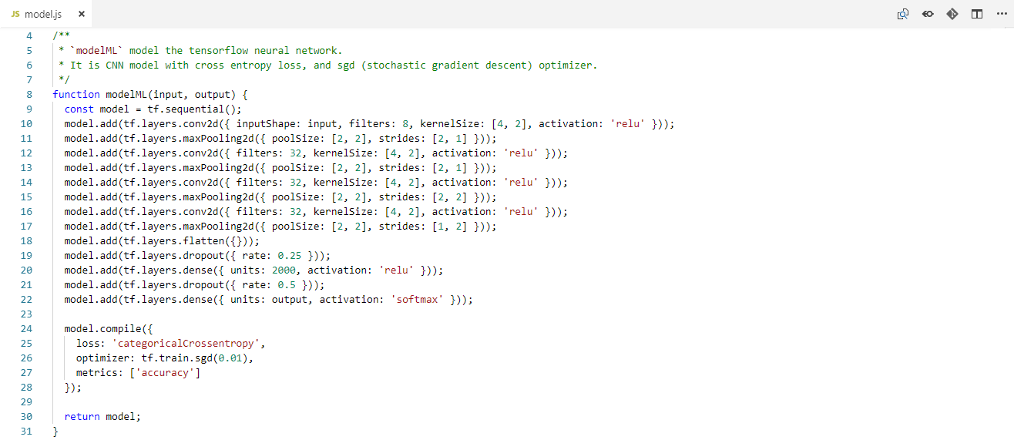

Figure 5.14 Train model modelML code.

#### train

train is used to setup and train the model based on model. It is written on JavaScript. The code is inspired from TensorFlow speech_commands [27] and TensorFlow.js speech_commands [28].

train contains extractWav, createMelFilterbank, loadData, nextBatch, train, and saveModelDB. loadData is used to load collected data from Collect application, split to train, validation, and test data, and run extractWav to extract all of them. extractWav is used MFCC to do extraction process. createMelFilterbank is used to create the filterbank model that is used by extractWav. The extraction is inspired from many sources, python_speech_features [29], node-mfcc [30], and meyda [31], as there are many variations in the process. In the process node-wav package [32] is used to decode the collected file in the beginning of extraction process. Also, dct package [33] is used to calculate DCT in the last step of extraction process.

When the data is loaded, it is shuffled by shuffle-array package [34] to reduce overfitting. Every iteration when extracting the loaded files is printed. If inconsistent data is met, the process stops and exit. Then, it loads model first, before run nextBatch, that is used to get portion of loadData result and convert it to model input output. It converts test data to be prepared for testing. After that train is run. At first, it converts train and validation data using nextBatch corresponding to train iteration. Then, it runs fit, that is provided by TensorFlow.js to train using train data and evaluate using validation data. fit is iterate based on the epoch that is defined.

Every train iteration evaluation result are printed. Test is run every n time in train iteration and last iteration. It uses predict to predict the test data and confusionMatrix to print all the test result. Both is provided by TensorFlow.js. Every test iteration the model saved with random name to avoid overwrite using crypto-random-string package [35]. It also run saveModelDB, that is used to insert the model to MongoDB.

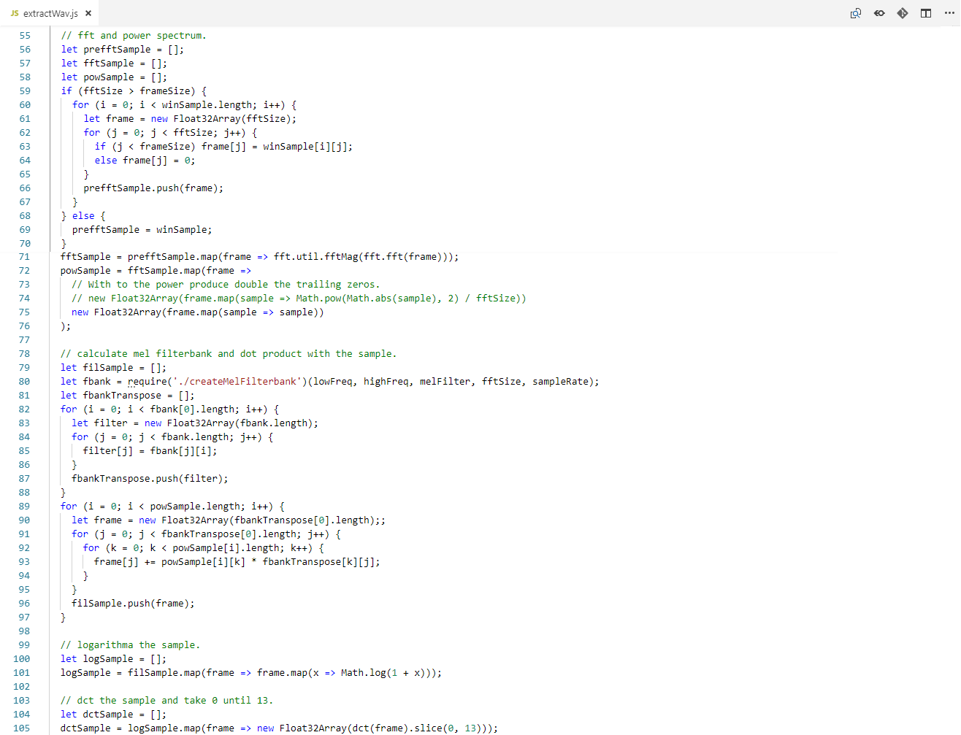

Figure 5.15 Some part of Train train extractWav code.

### Mimic Application

Mimic application code is used to create the front-end of Mimic application. It consists of home, identify, and generate.

#### home

home is used to render the Home page as shown in figure 5.4 and also handle the button in Home page. It is written on HTML and JavaScript.

home contains html, btnIdentify, btnGenerate, and btnCollect. html is used to render Home page. btnIdentify is used to direct user to Identify page. btnGenerate is used to direct user to Generate page. btnCollect is used to direct user to Collect Home page.

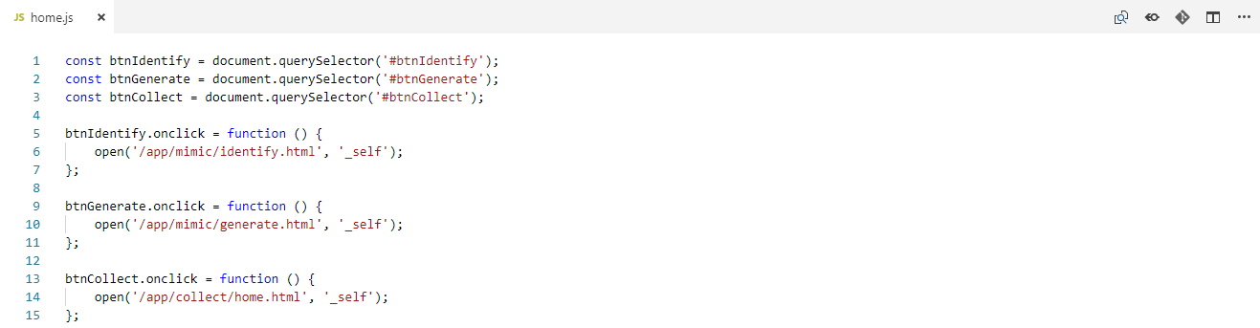

Figure 5.16 Mimic home html code.

#### identify

identify is used to render the Identify page as shown in figure 5.5 up to 5.7, handle the button and element in Identify page, and also handle upload and identify record. It is written on HTML and JavaScript.

identify contains html, inSpeechId, btnFinish, btnRecord, btnIdentify, captureUserMedia, postFiles, generateRandomString, xhrPostUploadCollect, and xhrPostIdentifySpeech. html is used to render Identify page. inSpeechId is used to place for user to input speech ID. btnFinish is used to redirect back to Home page.

btnRecord is used to start record same like Collect syllables btnRecord. btnIdentify is used to identify recorded speech. It alerts error to user if there is not any value in inSpeechId and recorded speech. It identifies by run xhrPostIdentifySpeech, that is used to send identify request with inSpeechId and recorded speech to the server and receive response from the server.

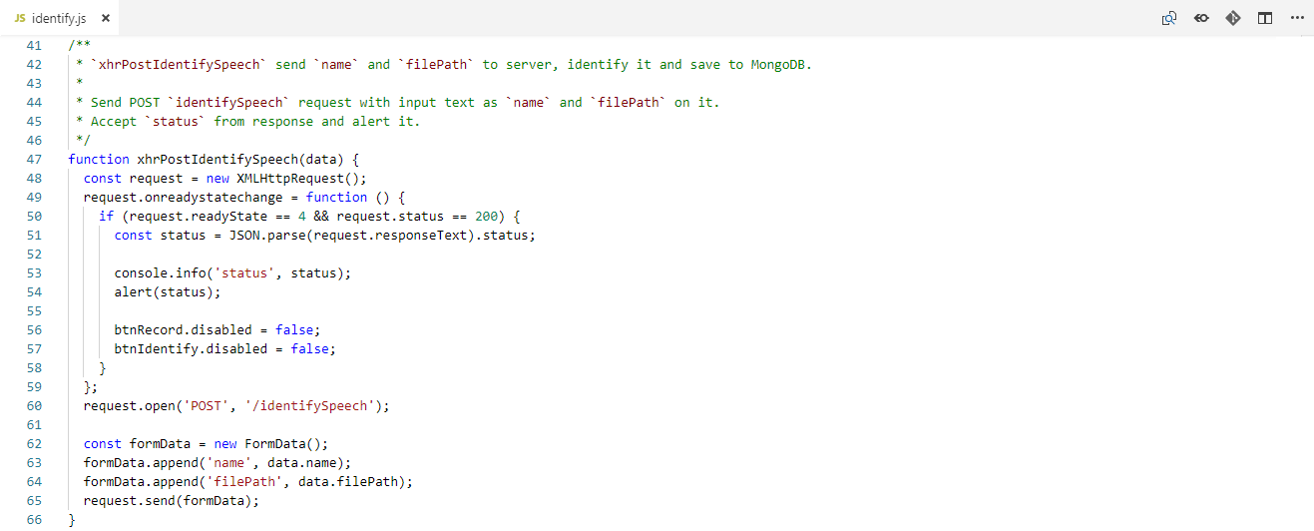

Figure 5.17 Mimic identify xhrPostIdentifySpeech code.

#### generate

generate is used to render the Generate page as shown in figure 5.8 up to 5.11, handle the button and element in Generate page, and also handle load and generate speech. It is written on HTML and JavaScript.

generate contains html, inSpeechId, listSpeechId, txtAreaText, btnFinish, btnGenerate, xhrGetSpeechId, and xhrPostGenerateSpeech. html is used to render Generate page. After render the page, it runs xhrGetSpeechId, that is used to send load request to the server and receive response from the server. The loads result which is speech data is stored to listSpeechId. If there is no speech data found, it alerts error to user and redirect user back to Home page.

inSpeechId is used to place for user to input speech ID that also show speech data list. txtAreaText is used to place for user to input text. btnFinish is used to redirect back to Home page. btnGenerate is used to generate speech. It alerts error to user if there is not any value in inSpeechId and txtAreaText or inputted speech ID in inSpeechId is not exist in listSpeechId. It generates by run xhrPostIdentifySpeech, that is used to send generate request with inSpeechId and txtAreaText to the server and receive response from the server.

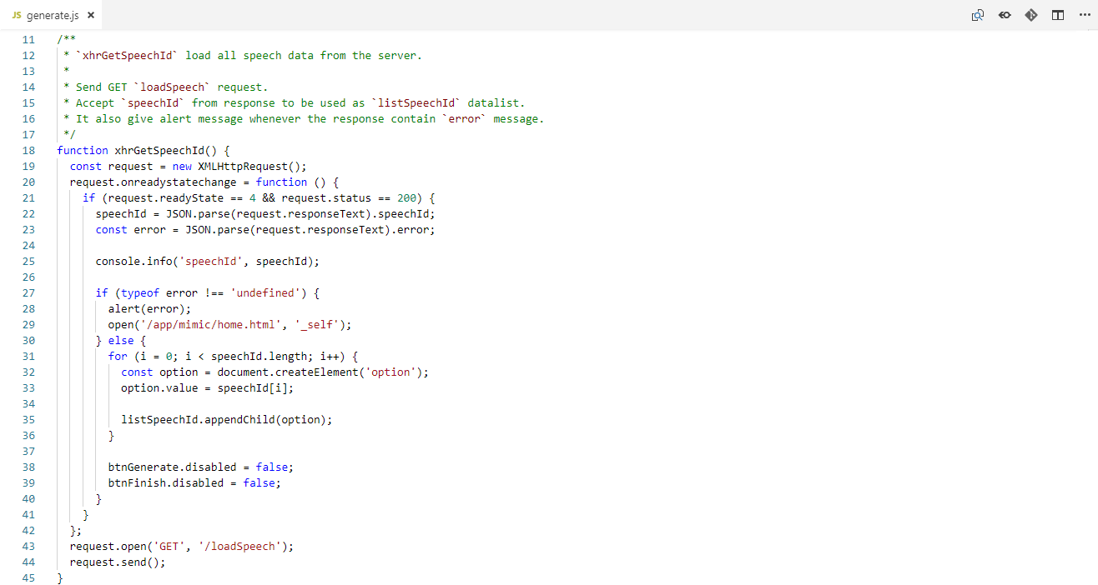

Figure 5.18 Mimic generate xhrPostIdentifySpeech code.

### Server Code

Server code is used to create the back-end of Collect and Mimic application. It consists of collect, identify, and generate routers, serverHandler and createServer. The server is inspired and forked from RecordRTC package [25]. The routers use formidable package [36] that is used to parse request data and upload file from request.

#### collect Router

collect router is used to handle upload request from Collect Syllables page that will be used by serverHandler. It is written on JavaScript.

collect router contains uploadCollect and router. router is used to check whether the request is from Collect Syllables page or not. If yes, it runs uploadCollect corresponding to matched syllable request. If no, it returns nothing. uploadCollect is used to upload file from the request to the directory that have the same syllable name in collect directory. It converts its upload path location to URL. It returns the URL as response.

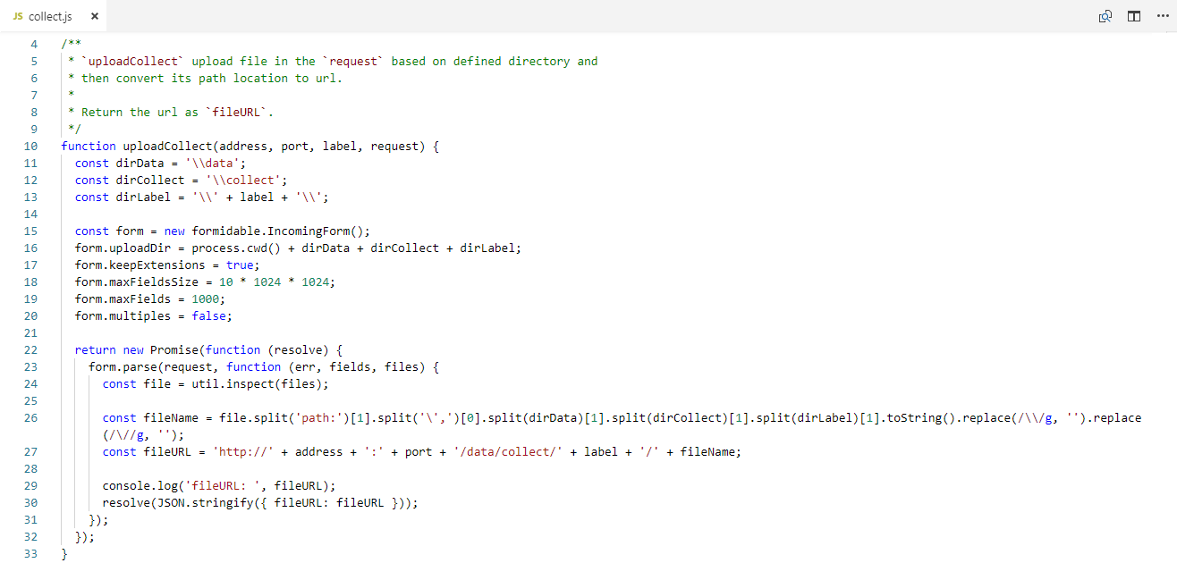

Figure 5.19 Server collect router uploadCollect code.

#### identify Router

identify router is used to handle upload request from Mimic Identify page that will be used by serverHandler. It is written on JavaScript.

identify router contains extractAndConvert, createMelFilterbank, uploadSpeech, identifySpeech, and router. router is used to check whether the request is from Mimic Identify page or not. If yes, it runs uploadSpeech or identifySpeech depends to matched request. If no, it returns nothing. uploadSpeech is used to upload file from the request same like collect router uploadCollect. The different are, uploadSpeech upload to the speech directory and returns the URL and upload path as response.

identifySpeech is used to identify the recorded file from request. First, it loads latest inserted trained model from MongoDB models collection. Then, it runs extractAndConvert alongside with createMelFilterbank ,that is used to extract the file and convert to model input same like extractWav and nextBatch combined, then feed it to model. Error connection or found model will return the information as response. Unsatisfied identification or results below 0.75 (75%) from identification also will return information as response. If none of those is occurred, which means model identify the recorded file with high accuracy, will update the MongoDB speechDatas collection based on its speech ID from the request and identified syllable. Then it returns the information as response.

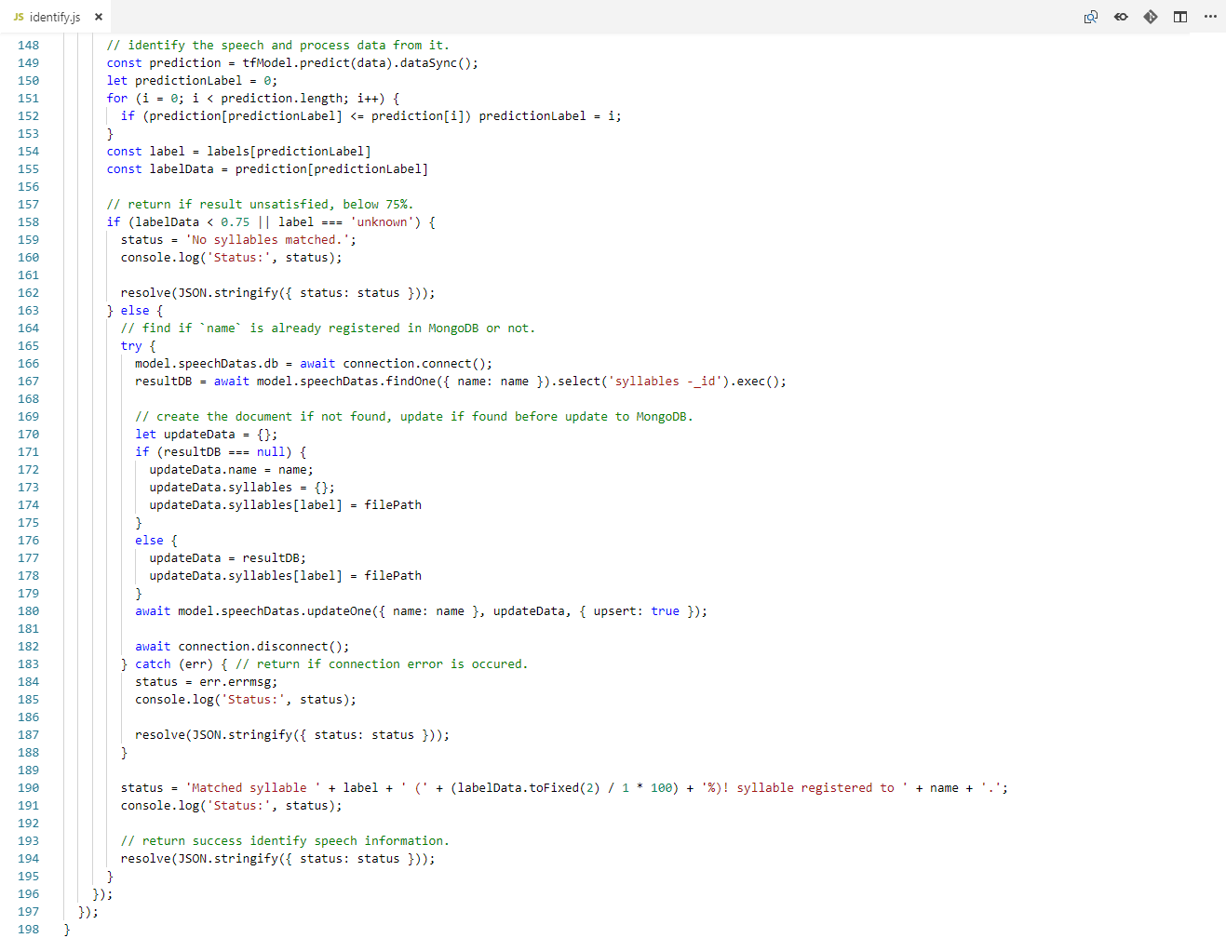

Figure 5.20 Some part of Server identify router identifySpeech code.

#### generate Router

generate router is used to handle upload request from Mimic Generate page that will be used by serverHandler. It is written on JavaScript.

generate router contains loadSpeech, generateSpeech, and router. router is used to check whether the request is from Mimic Generate page or not. If yes, it runs loadSpeech or generateSpeech depends to matched request. If no, it returns nothing. loadSpeech is used to load all registered speech ID from MongoDB speechDatas collection. If error connection or no speech ID is found it return error message as response. If not, it returns the load result as response.

generateSpeech is used to generate speech based on text from the request. First, it loads registered syllables from MongoDB speechDatas collection based on speech ID from the request. Error connection will return error message as response. Then, the text is extracted by check to loaded syllable one by one. If unmatched is found, it returns error as response. If all matched, the extract result is decoded and combined to 1 audio file. the speech data corresponding to extract result is combined to 1 audio with node-wav package, encode and decode [32]. The audio file is saved into generate directory. It converts its file path location to URL. It returns the URL as response.

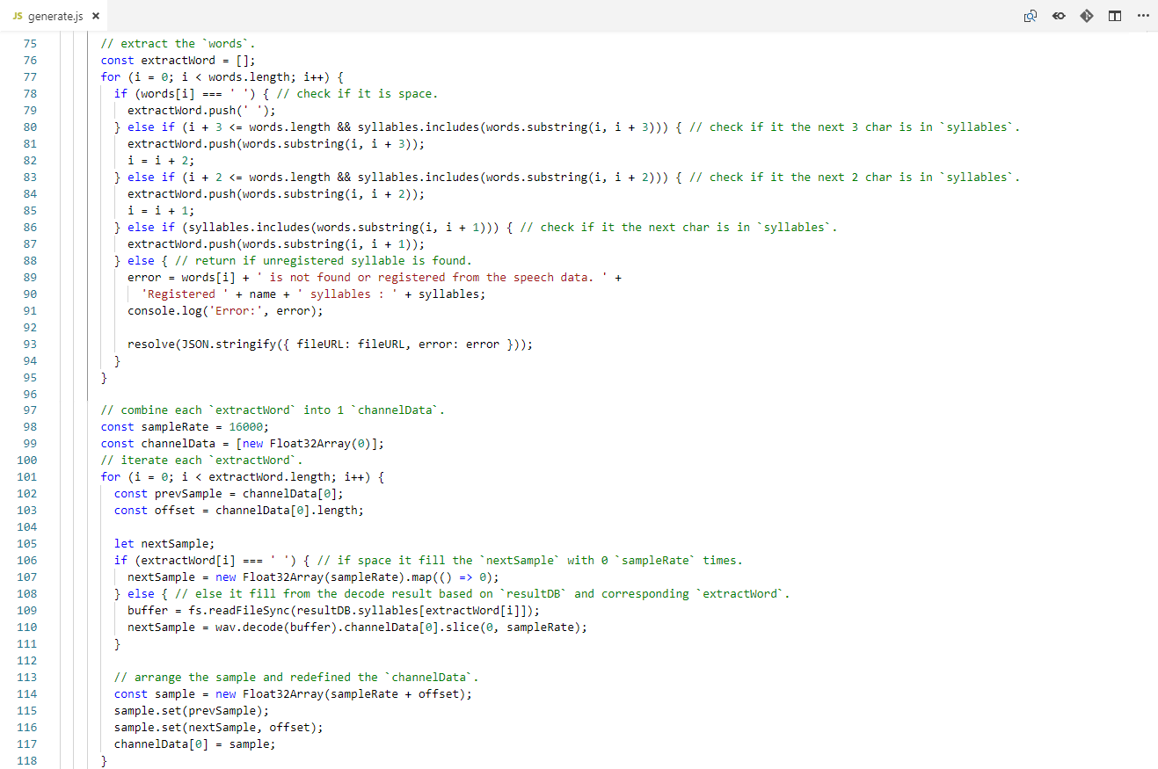

Figure 5.21 Some part of Server genearte router generateSpeech code.

#### serverHandler

serverHandler is used to define server listener, collect, identify, generate router and file handler, that will be used by createServer. It is written on JavaScript.

serverHandler contains fileHandler. It first will import collect, identify, and generate router to check whether the request is for them or not. If yes, it runs to corresponding router depends to matched request. As it returns response it also returns 200 that means the request is successful [37]. If no, it run fileHandler. fileHandler is used to check whether the corresponding URL has file in the directory. If the file doesn’t exist it returns 404, that means the requested resource could not be found [37], to the browser. If the file does exist but cannot be read or displayed, it returns 500, that means unexpected condition was encountered and no more specific message is suitable [37], to the browser. And if the file does exist and can be read or displayed, it will return the binary so that the browser can load and display alongside with 200.

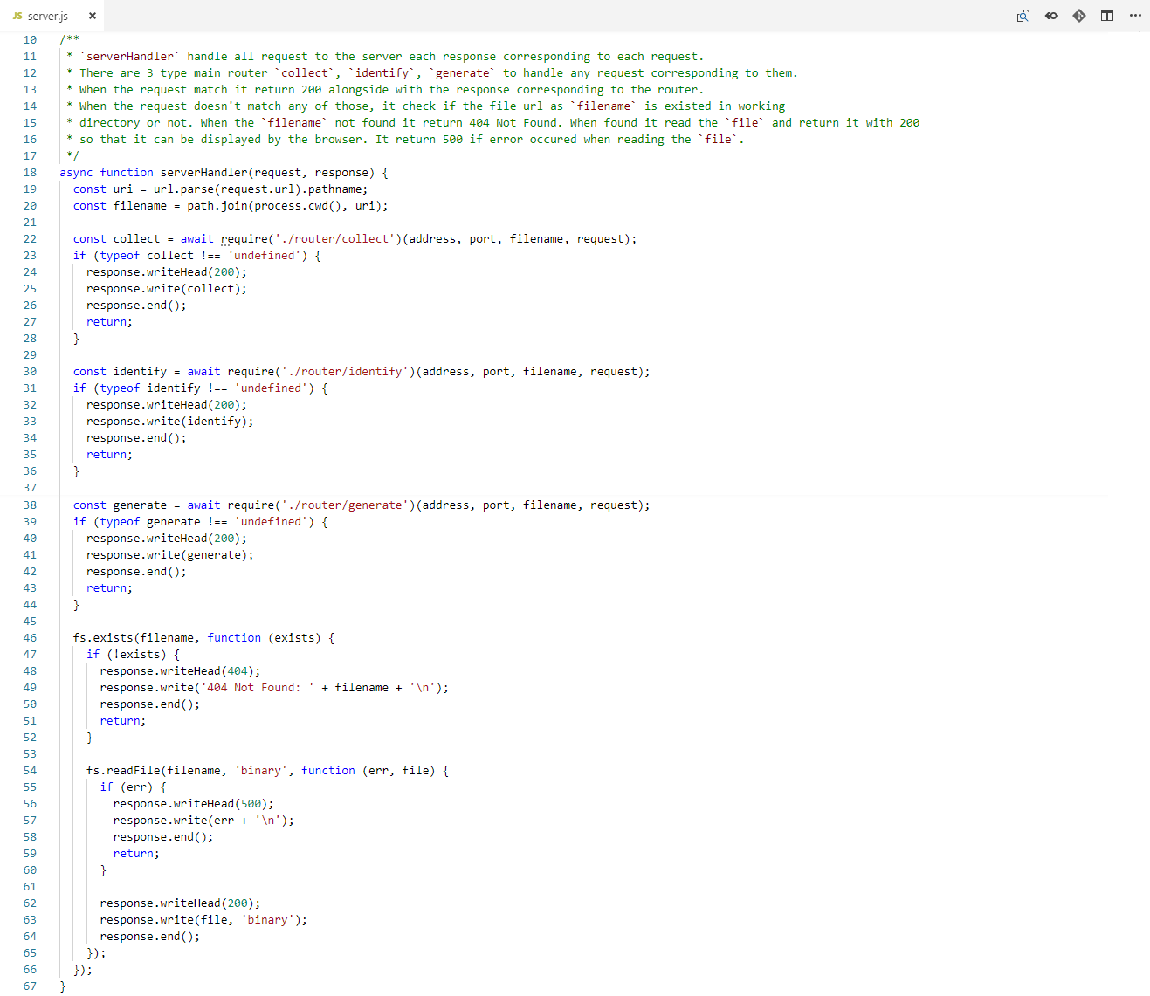

Figure 5.22 Server serverHandler code.

#### createServer

createServer is used to create http server in the computer that use serverHandler as request listener. It is written on JavaScript.

createServer contains createServer and listen. createServer is used to create the server and followed by listen that is used to listening for connection that comes to the server. It listens on defined host and port. When the server established, it prints information in console.

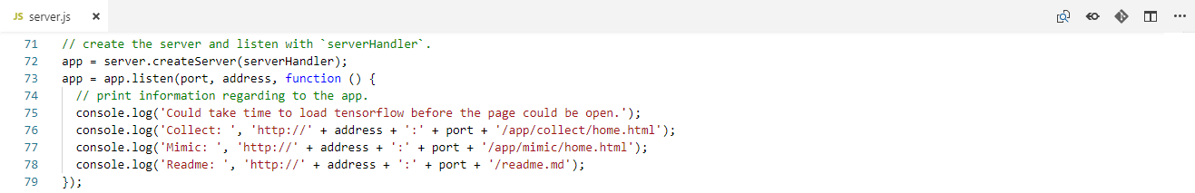

Figure 5.23 Server createServer code.

### Database Code

Database code is used to connection to MongoDB and collection model scheme of the database on MongoDB. It consists of connection and model.

#### connection

connection is used to handle the connection with MongoDB. It is written on JavaScript.

connection contains connect and disconnect methods. connect is used to establish the connection to MongoDB mimic_speech database on localhost. disconnect is used to close the established connection with MongoDB.

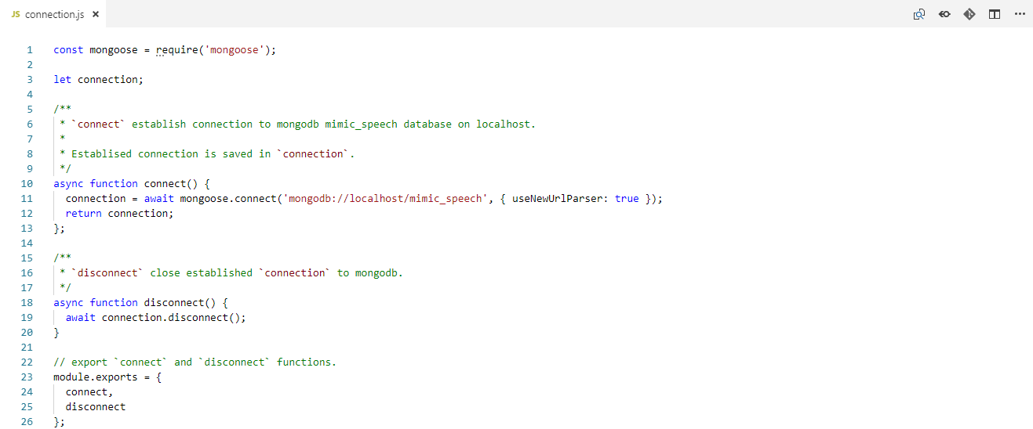

Figure 5.24 Database connection code.

#### model

model is used to create the collection model scheme of the database on MongoDB. It is written on JavaScript.

model contains speechDatas and models methods. speechDatas is used to define scheme with name as string and syllables as object. speechDatas scheme model is used for store the speech data. name is speech ID and syllables is the registered syllables by the corresponding speech ID. models is used to define scheme with location as string and createAt as date with current date being default value when create or update collection when createAt is not defined. models scheme model is used for store the machine learning model. location is the model location path in directory and createAt is the date when the model is created or saved to MongoDB.

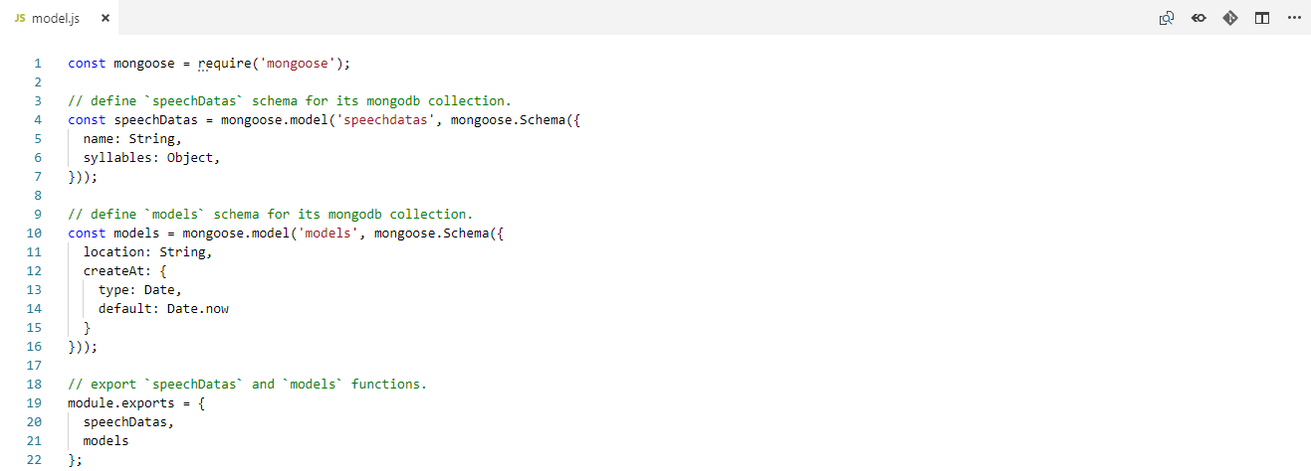

Figure 5.25 Database model code.

# SYSTEM TESTING

## Testing Environment

The testing environment specify the environment during testing. The environment specification are as follows:

1. Windows 10.
2. Chrome browser.

There is additional environment only on the identify process. Male user that the records is trained by the application is called Tester 1. Female user that the records is trained by the application is called Tester 2. Male user that the record hasn’t trained by the application called Tester 3. Female user that the record hasn’t trained by the application called Tester 4. Every tester is test in each the following environment:

1. Noisy background (Loud music or people chit-chat).
2. Semi noisy background (Rain noise or sound from the other rooms).
3. Not noisy background.

## Testing Scenario

The testing scenario conducted by evaluating all the features with a set of cases or scenario in the application based on its functionality requirement and defined testing environment.

The testing scenarios of the application is categorized based on Collect application, Train application, and Mimic application.

### Collect Application

The Collect application has 3 subcategorized scenarios, Collect server, Home page and Syllables page. The Collect server has scenarios to allow user to access Home page, Syllables page in the browser and process the upload record request. The Home page has scenarios to allow user to direct to Syllables page to start the Collect application and direct to Mimic application Home page to change to Mimic application. Syllables page has scenarios to allow user to upload the record to the server and direct to the next Syllables page or direct back to Home page.

Table 6.1 Collect application scenarios.

|  |  |  |  |
| --- | --- | --- | --- |
| **No** | **Scenario** | **Expected Result** | **Result** |
| 1 | Access Home page | Home page is shown | As expected |
| 2 | Access Syllables page | Syllables page is shown | As expected |
| 3 | Process upload record request | Printed process results information on the console | As expected |
| 4 | Direct to Syllables page | Directed to Syllables page | As expected |
| 5 | Direct to Mimic application Home page | Directed to Mimic application Home page | As expected |
| 6 | Upload the record | Audio element is shown with the user record | As expected |
| 7 | Direct to the next Syllables page or direct back to Home page | Directed to the next Syllables page or Directed back to Home Page | As expected |

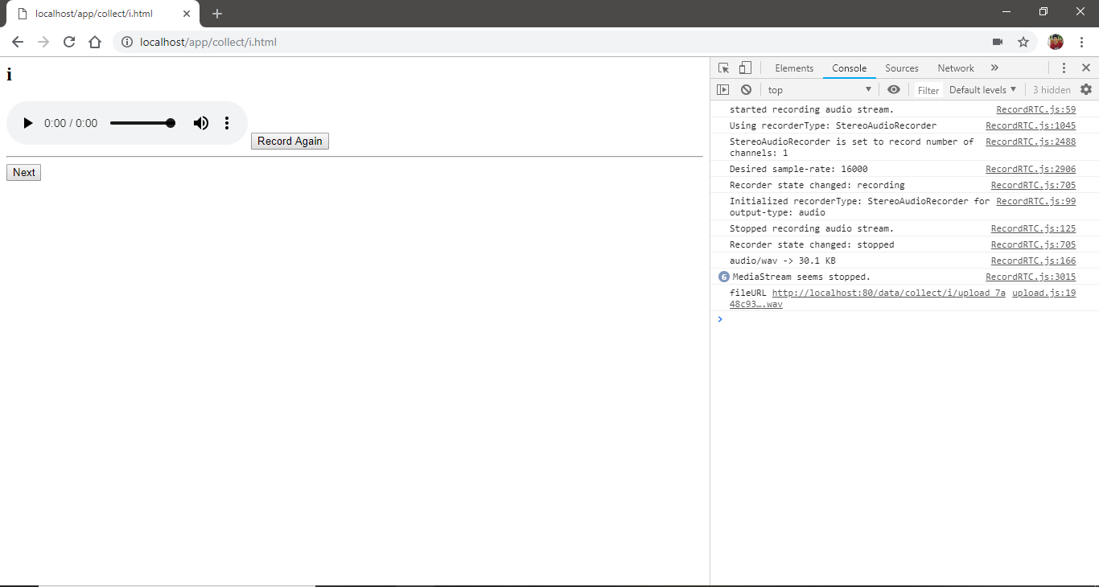

Figures 6.1 Screenshot of process upload record request scenario from Collect application.

### Train Application

The Train application has scenario to allows user to train model with collected data. When train is run, it loads and splits collected data, extracts the data, gets the corresponding batch data, trains the TensorFlow model to fit the batch train data, tests the TensorFlow model from test data, and saves the TensorFlow model to database.

Table 6.2 Train application scenarios.

|  |  |  |  |
| --- | --- | --- | --- |
| **No** | **Scenario** | **Expected Result** | **Result** |
| 1 | Load and split collected data | Printed information on the console | As expected |
| 2 | Extract the data | Printed information on the console | As expected |
| 3 | Get corresponding batch data | Printed information on the console | As expected |
| 4 | Train the TensorFlow model to fit batch train data | Printed information on the console | As expected |
| 5 | Test the TensorFlow model from test data | Printed information on the console | As expected |
| 6 | Save the TensorFlow model to database | Recorded document in mimic_speech database models collection | As expected |

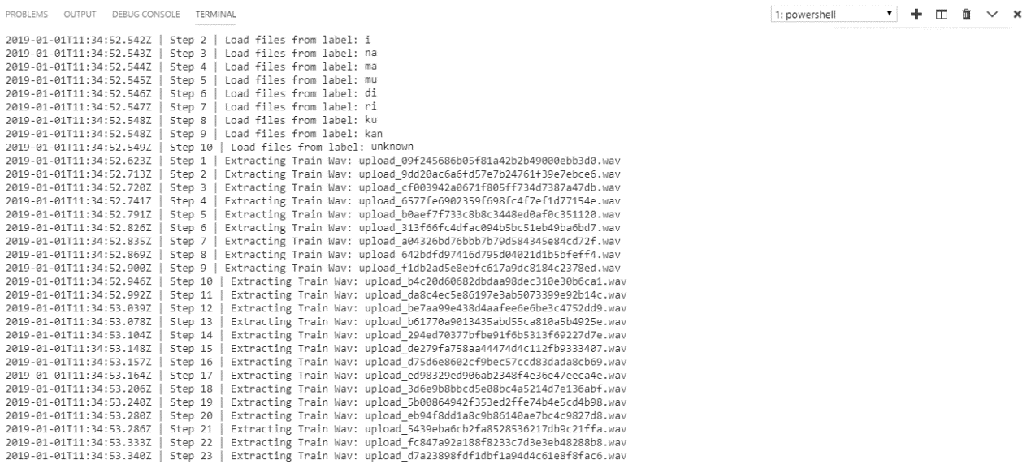

Figures 6.2 Screenshot of load and split collected data and extract the data scenarios from Train application.

### Mimic Application

The Mimic application has 4 subcategorized scenarios, Mimic server, Home page, Identify page, and Generate page. The Mimic server has scenarios to allow user to access Home page, Identify page, and Generate page in the browser and process the upload record and identify speech on Identify request and load speech data and generate speech on Generate request. The Home page has scenarios to allow user to direct to Identify page to start the identify speech application, direct to Generate page to start the generate speech application, and direct to Collect application Home page to change to Collect application. The Identify page has scenarios to allow user to upload the record to the server, send form request for identify speech to the server, and direct back to Home page. The Generate page has scenarios to allow user to load speech data from the server, send form request for generate speech to the server, and direct back to Home page.

Table 6.3 Mimic application scenarios.

|  |  |  |  |
| --- | --- | --- | --- |
| **No** | **Scenario** | **Expected Result** | **Result** |
| 1 | Access Home page | Home page is shown | As expected |
| 2 | Access Identify page | Identify page is shown | As expected |
| 3 | Access Generate page | Generate page is shown | As expected |
| 3 | Process upload record on Identify request | Printed process results information on the console | As expected |
| 4 | Process identify speech on Identify request | Printed process results information on the console | As expected |
| 5 | Process load speech data on Generate request | Printed process results information on the console | As expected |
| 6 | Process generate speech on Generate request | Printed process results information on the console | As expected |
| 7 | Direct to Identify page | Directed to Identify page | As expected |
| 8 | Direct to Generate page | Directed to Generate page | As expected |
| 9 | Direct to Collect application Home page | Directed to Collect application Home page | As expected |
| 10 | Upload the record | Audio element is shown with the user record | As expected |
| 11 | Send form for identify speech | Alert information despite success or error in the process | As expected |
| 12 | Direct back to Home page from Identify page | Directed back to Home Page | As expected |
| 13 | Load speech data | Datalist element store the speech data or alert if no speech data is found | As expected |
| 14 | Send form for generate speech | Audio element is shown with the generated speech or alert if error is occurred | As expected |
| 15 | Direct back to Home page from Generate page | Directed back to Home Page | As expected |

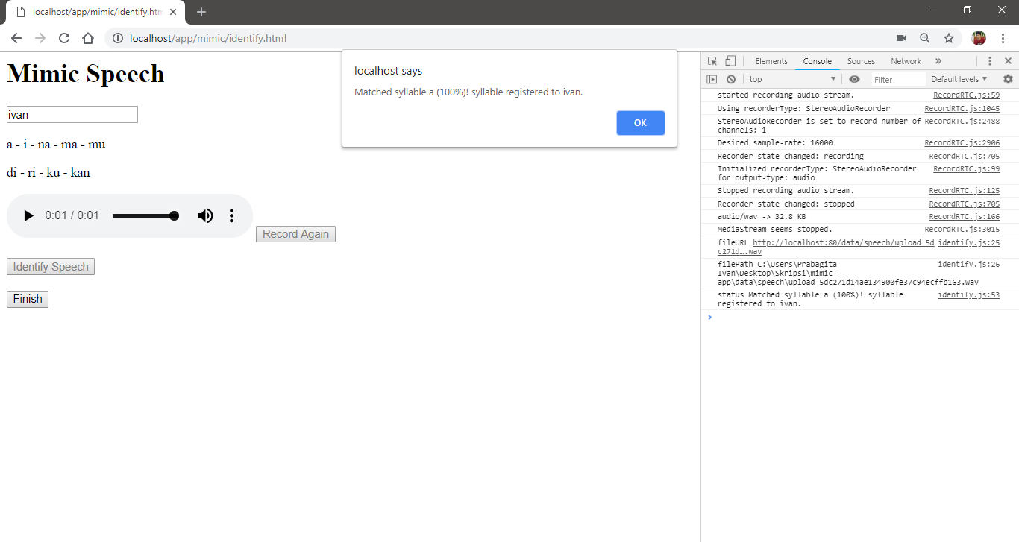

Figures 6.3 Screenshot of process identify speech on Identify request scenario from Mimic application.

The dataset during the speech recognition testing on identify process is 10000 male and female speech data, each 500 on each syllable, on not noisy background and each 500 unknown sound. Corrected result shows from the more than 75% of model accuracy. The table also fill with accuracy with the syllable result along with it. Random or unknown condition is tested with silent condition, o, and mi syllables. The following tests table results below and figures that shows some screenshot of identify process results:

Table 6.4 Tester 1 results on noisy background.

|  |  |  |  |  |  |
| --- | --- | --- | --- | --- | --- |
| **No** | **Spoken Syllable** | **Noisy Background** | | | **Correct Result** |
| **1** | **2** | **3** |
| 1 | a | 52  *(a)* | 100  *(a)* | 100  *(unknown)* | 1/3 |
| 2 | i | 62  *(na)* | 85  *(ri)* | 96  *(ma)* | 0/3 |
| 3 | na | 100  *(unknown)* | 86  *(kan)* | 100  *(unknown)* | 0/3 |
| 4 | ma | 100  *(a)* | 84  *(unknown)* | 100  *(a)* | 0/3 |
| 5 | mu | 99  *(kan)* | 71  *(ku)* | 88  *(unknown)* | 0/3 |

|  |  |  |  |  |  |
| --- | --- | --- | --- | --- | --- |
| 6 | di | 59  *(mu)* | 100  *(ri)* | 97  *(ri)* | 0/3 |
| 7 | ri | 50  *(na)* | 100  *(ri)* | 92  *(a)* | 1/3 |
| 8 | ku | 100  *(ku)* | 85  *(a)* | 100  *(kan)* | 1/3 |
| 9 | kan | 72  *(unknown)* | 61  *(kan)* | 79  *(kan)* | 3/3 |
| 10 | Unknown 1  *(silent)* | 99  *(unknown)* | 100  *(a)* | 99  *(unknown)* | 2/3 |
| 11 | Unknown 2  *(o)* | 100  *(na)* | 100  *(a)* | 100  *(ku)* | 0/3 |
| 12 | Unknown 3  *(mi)* | 100  *(a)* | 51  *(kan)* | 96  *(ma)* | 1/3 |

Table 6.5 Tester 1 results on semi noisy background.

|  |  |  |  |  |  |
| --- | --- | --- | --- | --- | --- |
| **No** | **Spoken Syllable** | **Semi Noisy Background** | | | **Correct Result** |
| **1** | **2** | **3** |
| 1 | a | 100  *(a)* | 100  *(a)* | 100  *(a)* | 3/3 |
| 2 | i | 100  *(i)* | 36  *(ri)* | 100  *(i)* | 2/3 |
| 3 | na | 97  *(mu)* | 48  *(ma)* | 99  *(na)* | 1/3 |
| 4 | ma | 49  *(i)* | 98  *(ri)* | 79  *(mu)* | 0/3 |
| 5 | mu | 55  *(ri)* | 99  *(ku)* | 50  *(ri)* | 0/3 |
| 6 | di | 57  *(i)* | 100  *(di)* | 100  *(i)* | 1/3 |
| 7 | ri | 100  *(ri)* | 75  *(ri)* | 100  *(ri)* | 3/3 |
| 8 | ku | 92  *(ku)* | 68  *(ku)* | 91  *(ku)* | 2/3 |
| 9 | kan | 100  *(kan)* | 94  *(na)* | 100  *(kan)* | 2/3 |
| 10 | Unknown 1  *(silent)* | 100  *(a)* | 99  *(unknown)* | 100  *(ma)* | 2/3 |
| 11 | Unknown 2  *(o)* | 100  *(ku)* | 89  *(ku)* | 72  *(ku)* | 1/3 |
| 12 | Unknown 3  *(mi)* | 100  *(ri)* | 94  *(ri)* | 100  *(ri)* | 0/3 |

Table 6.6 Tester 1 results on not noisy background.

|  |  |  |  |  |  |
| --- | --- | --- | --- | --- | --- |
| **No** | **Spoken Syllable** | **Not Noisy Background** | | | **Correct Result** |
| **1** | **2** | **3** |
| 1 | a | 100  (a) | 100  (a) | 100  (a) | 3/3 |
| 2 | i | 94  (i) | 48  (kan) | 94  (i) | 2/3 |
| 3 | na | 80  (na) | 99  (na) | 100  (na) | 3/3 |
| 4 | ma | 96  (di) | 90  (i) | 57  (di) | 0/3 |
| 5 | mu | 100  (i) | 86  (ku) | 95  (i) | 0/3 |
| 6 | di | 99  *(ri)* | 100  *(i)* | 80  *(ri)* | 0/3 |
| 7 | ri | 100  *(ri)* | 96  *(ri)* | 91  *(ri)* | 3/3 |
| 8 | ku | 85  *(ku)* | 96  *(ku)* | 100  *(ku)* | 3/3 |
| 9 | kan | 92  *(kan)* | 100  *(kan)* | 100  *(kan)* | 3/3 |
| 10 | Unknown 1  *(silent)* | 98  *(unknown)* | 98  *(unknown)* | 98  *(unknown)* | 3/3 |
| 11 | Unknown 2  *(o)* | 100  *(ku)* | 98  *(ku)* | 65  *(ku)* | 1/3 |
| 12 | Unknown 3  *(mi)* | 54  *(mu)* | 100  *(ri)* | 67  *(mu)* | 2/3 |

Table 6.7 Tester 2 results on noisy background.

|  |  |  |  |  |  |
| --- | --- | --- | --- | --- | --- |
| **No** | **Spoken Syllable** | **Noisy Background** | | | **Correct Result** |
| **1** | **2** | **3** |
| 1 | a | 99  *(unknown)* | 99  *(a)* | 99  *(a)* | 2/3 |
| 2 | i | 82  *(unknown)* | 98  *(ma)* | 99  *(ri)* | 0/3 |
| 3 | na | 52  *(ri)* | 99  *(ma)* | 61  *(ma)* | 0/3 |
| 4 | ma | 50  *(unknown)* | 37  *(unknown)* | 95  *(ri)* | 0/3 |
| 5 | mu | 99  *(unknown)* | 52  *(di)* | 99  *(unknown)* | 0/3 |
| 6 | di | 99  *(i)* | 99  *(unknown)* | 99  *(unknown)* | 0/3 |
| 7 | ri | 86  *(i)* | 20  *(kan)* | 57  *(di)* | 0/3 |
| 8 | ku | 99  *(ku)* | 68  *(kan)* | 90  *(unknown)* | 1/3 |
| 9 | kan | 84  *(kan)* | 99  *(kan)* | 78  *(a)* | 2/3 |
| 10 | Unknown 1  *(silent)* | 100  *(unknown)* | 100  *(unknown)* | 100  *(unknown)* | 3/3 |
| 11 | Unknown 2  *(o)* | 99  *(ma)* | 99  *(ku)* | 99  *(ku)* | 0/3 |
| 12 | Unknown 3  *(mi)* | 36  *(di)* | 96  *(mu)* | 99  *(di)* | 1/3 |

Table 6.8 Tester 2 results on semi noisy background.

|  |  |  |  |  |  |
| --- | --- | --- | --- | --- | --- |
| **No** | **Spoken Syllable** | **Semi Noisy Background** | | | **Correct Result** |
| **1** | **2** | **3** |
| 1 | a | 100  *(a)* | 100  *(unknown)* | 99  *(a)* | 2/3 |
| 2 | i | 92  *(ri)* | 97  *(unknown)* | 96  *(ri)* | 0/3 |
| 3 | na | 83  *(ma)* | 62  *(unknown)* | 75  *(kan)* | 0/3 |
| 4 | ma | 87  *(unknown)* | 64  *(ma)* | 90  *(na)* | 2/3 |
| 5 | mu | 76  *(ma)* | 78  *(ku)* | 66  *(di)* | 0/3 |
| 6 | di | 58  *(mu)* | 48  *(mu)* | 30  *(kan)* | 0/3 |
| 7 | ri | 99  *(kan)* | 89  *(kan)* | 99  *(ri)* | 1/3 |
| 8 | ku | 99  *(unknown)* | 99  *(ku)* | 88  *(unknown)* | 1/3 |
| 9 | kan | 99  *(kan)* | 65  *(kan)* | 85  *(kan)* | 2/3 |
| 10 | Unknown 1  *(silent)* | 100  *(unknown)* | 79  *(a)* | 99  *(ri)* | 1/3 |
| 11 | Unknown 2  *(o)* | 99  *(a)* | 82  *(ku)* | 99  *(na)* | 0/3 |
| 12 | Unknown 3  *(mi)* | 89  *(kan)* | 35  *(ku)* | 96  *(ri)* | 1/3 |

Table 6.9 Tester 2 results on not noisy background.

|  |  |  |  |  |  |
| --- | --- | --- | --- | --- | --- |
| **No** | **Spoken Syllable** | **Not Noisy Background** | | | **Correct Result** |
| **1** | **2** | **3** |
| 1 | a | 88  *(a)* | 99  *(a)* | 99  *(a)* | 3/3 |
| 2 | i | 99  *(i)* | 99  *(i)* | 52  *(i)* | 2/3 |
| 3 | na | 97  *(a)* | 54  *(kan)* | 99  *(a)* | 0/3 |
| 4 | ma | 99  *(na)* | 99  *(na)* | 98  *(na)* | 0/3 |
| 5 | mu | 81  *(i)* | 95  *(i)* | 44  *(i)* | 0/3 |
| 6 | di | 99  *(i)* | 36  *(i)* | 96  *(i)* | 0/3 |
| 7 | ri | 47  *(ri)* | 32  *(unknown)* | 48  *(i)* | 0/3 |
| 8 | ku | 98  *(ku)* | 67  *(kan)* | 99  *(ku)* | 2/3 |
| 9 | kan | 84  *(na)* | 85  *(na)* | 87  *(na)* | 0/3 |
| 10 | Unknown 1  *(silent)* | 99  *(unknown)* | 99  *(unknown)* | 100  *(unknown)* | 3/3 |
| 11 | Unknown 2  *(o)* | 100  *(ku)* | 99  *(ku)* | 95  *(ku)* | 0/3 |
| 12 | Unknown 3  *(mi)* | 67  *(ri)* | 78  *(di)* | 77  *(i)* | 1/3 |

Table 6.10 Tester 3 results on noisy background.

|  |  |  |  |  |  |
| --- | --- | --- | --- | --- | --- |
| **No** | **Spoken Syllable** | **Noisy Background** | | | **Correct Result** |
| **1** | **2** | **3** |
| 1 | a | 100  *(a)* | 99  *(a)* | 100  *(a)* | 3/3 |
| 2 | i | 71  *(ma)* | 99  *(ri)* | 99  *(ri)* | 0/3 |
| 3 | na | 70  *(ku)* | 99  *(a)* | 57  *(unknown)* | 0/3 |
| 4 | ma | 99  *(a)* | 100  *(a)* | 100  *(a)* | 0/3 |
| 5 | mu | 74  *(mu)* | 96  *(kan)* | 74  *(mu)* | 0/3 |
| 6 | di | 99  *(ri)* | 96  *(ri)* | 89  *(ri)* | 0/3 |
| 7 | ri | 100  *(unknown)* | 90  *(na)* | 86  *(a)* | 0/3 |
| 8 | ku | 98  *(kan)* | 64  *(mu)* | 99  *(a)* | 0/3 |
| 9 | kan | 99  *(na)* | 100  *(kan)* | 98  *(kan)* | 2/3 |
| 10 | Unknown 1  *(silent)* | 99  *(a)* | 99  *(a)* | 100  *(a)* | 0/3 |
| 11 | Unknown 2  *(o)* | 92  *(na)* | 84  *(na)* | 61  *(mu)* | 1/3 |
| 12 | Unknown 3  *(mi)* | 64  *(kan)* | 53  *(na)* | 99  *(ri)* | 2/3 |

Table 6.11 Tester 3 results on semi noisy background.

|  |  |  |  |  |  |
| --- | --- | --- | --- | --- | --- |
| **No** | **Spoken Syllable** | **Semi Noisy Background** | | | **Correct Result** |
| **1** | **2** | **3** |
| 1 | a | 100  *(a)* | 99  *(a)* | 99  *(a)* | 3/3 |
| 2 | i | 99  *(ri)* | 90  *(di)* | 92  *(di)* | 0/3 |
| 3 | na | 100  *(kan)* | 99  *(kna)* | 92  *(ma)* | 0/3 |
| 4 | ma | 99  *(a)* | 100  *(kan)* | 100  *(kan)* | 0/3 |
| 5 | mu | 99  *(mu)* | 99  *(mu)* | 65  *(ku)* | 2/3 |
| 6 | di | 99  *(ri)* | 100  *(ri)* | 99  *(ri)* | 0/3 |
| 7 | ri | 95  *(kan)* | 76  *(i)* | 78  *(di)* | 0/3 |
| 8 | ku | 99  *(a)* | 96  *(a)* | 100  *(a)* | 0/3 |
| 9 | kan | 99  *(a)* | 96  *(a)* | 99  *(a)* | 0/3 |
| 10 | Unknown 1  *(silent)* | 99  *(ri)* | 73  *(di)* | 60  *(unknown)* | 2/3 |
| 11 | Unknown 2  *(o)* | 100  *(a)* | 99  *(ku)* | 100  *(a)* | 0/3 |
| 12 | Unknown 3  *(mi)* | 99  *(na)* | 99  *(ri)* | 99  *(i)* | 0/3 |

Table 6.12 Tester 3 results on not noisy background.

|  |  |  |  |  |  |
| --- | --- | --- | --- | --- | --- |
| **No** | **Spoken Syllable** | **Not Noisy Background** | | | **Correct Result** |
| **1** | **2** | **3** |
| 1 | a | 100  *(a)* | 100  *(a)* | 100  *(a)* | 3/3 |
| 2 | i | 92  *(ri)* | 95  *(ri)* | 41  *(ku)* | 0/3 |
| 3 | na | 99  *(na)* | 74  *(ku)* | 80  *(a)* | 1/3 |
| 4 | ma | 59  *(a)* | 84  *(ku)* | 48  *(kan)* | 0/3 |
| 5 | mu | 99  *(mu)* | 99  *(ri)* | 99  *(ri)* | 1/3 |
| 6 | di | 100  *(ri)* | 99  *(i)* | 99  *(i)* | 0/3 |
| 7 | ri | 99  *(ri)* | 96  *(ri)* | 94  *(i)* | 2/3 |
| 8 | ku | 73  *(di)* | 100  *(mu)* | 99  *(mu)* | 0/3 |
| 9 | kan | 100  *(kan)* | 99  *(kan)* | 96  *(kan)* | 3/3 |
| 10 | Unknown 1  *(silent)* | 98  *(unknown)* | 98  *(unknown)* | 98  *(unknown)* | 3/3 |
| 11 | Unknown 2  *(o)* | 99  *(ku)* | 68  *(mu)* | 100  *(ku)* | 1/3 |
| 12 | Unknown 3  *(mi)* | 99  *(ri)* | 93  *(i)* | 100  *(ri)* | 0/3 |

Table 6.13 Tester 4 results on noisy background.

|  |  |  |  |  |  |
| --- | --- | --- | --- | --- | --- |
| **No** | **Spoken Syllable** | **Noisy Background** | | | **Correct Result** |
| **1** | **2** | **3** |
| 1 | a | 100  *(unknown)* | 99  *(unknown)* | 94  *(ma)* | 0/3 |
| 2 | i | 97  *(unknown)* | 99  *(ri)* | 99  *(ri)* | 0/3 |
| 3 | na | 100  *(na)* | 99  *(ri)* | 99  *(ma)* | 1/3 |
| 4 | ma | 93  *(na)* | 99  *(ma)* | 100  *(na)* | 1/3 |
| 5 | mu | 55  *(ri)* | 99  *(unknown)* | 43  *(unknown)* | 0/3 |
| 6 | di | 99  *(ri)* | 54  *(i)* | 99  *(ma)* | 0/3 |
| 7 | ri | 97  *(ri)* | 74  *(ri)* | 100  *(ri)* | 2/3 |
| 8 | ku | 68  *(ma)* | 92  *(ku)* | 52  *(52)* | 1/3 |
| 9 | kan | 48  *(ku)* | 22  *(ku)* | 99  *(a)* | 0/3 |
| 10 | Unknown 1  *(silent)* | 100 *(unknown)* | 100  *(unknown)* | 100 *(unknown)* | 3/3 |
| 11 | Unknown 2  *(o)* | 100  *(a)* | 100  *(a)* | 100  *(a)* | 0/3 |
| 12 | Unknown 3 *(mi)* | 55  *(mu)* | 99  *(ri)* | 94  *(i)* | 1/3 |

Table 6.14 Tester 4 results on semi noisy background.

|  |  |  |  |  |  |
| --- | --- | --- | --- | --- | --- |
| **No** | **Spoken Syllable** | **Semi Noisy Background** | | | **Correct Result** |
| **1** | **2** | **3** |
| 1 | a | 73  *(a)* | 91  *(unknown)* | 99  *(unknown)* | 0/3 |
| 2 | i | 81  *(ri)* | 99  *(i)* | 100  *(ri)* | 1/3 |
| 3 | na | 100  *(ma)* | 99  *(unknown)* | 99  *(unknown)* | 0/3 |
| 4 | ma | 99  *(ma)* | 99  *(na)* | 78  *(ma)* | 2/3 |
| 5 | mu | 81  *(unknown)* | 99  *(unknown)* | 99  *(unknown)* | 0/3 |
| 6 | di | 100  *(ri)* | 99  *(i)* | 99  *(i)* | 0/3 |
| 7 | ri | 85  *(ri)* | 99  *(ri)* | 98  *(ri)* | 3/3 |
| 8 | ku | 96  *(ku)* | 89  *(ku)* | 99  *(a)* | 2/3 |
| 9 | kan | 100  *(a)* | 99  *(a)* | 64  *(ma)* | 0/3 |
| 10 | Unknown 1  *(silent)* | 99  *(unknown)* | 99  *(ri)* | 100  *(unknown)* | 2/3 |
| 11 | Unknown 2  *(o)* | 99  *(a)* | 100  *(a)* | 99  *(a)* | 0/3 |
| 12 | Unknown 3  *(mi)* | 43  *(a)* | 59  *(ri)* | 99  *(unknown)* | 3/3 |

Table 6.15 Tester 4 results on not noisy background.

|  |  |  |  |  |  |
| --- | --- | --- | --- | --- | --- |
| **No** | **Spoken Syllable** | **Not Noisy Background** | | | **Correct Result** |
| **1** | **2** | **3** |
| 1 | a | 99  *(unknown)* | 75  *(a)* | 100  *(a)* | 2/3 |
| 2 | i | 88  *(i)* | 99  *(i)* | 99  *(ri)* | 2/3 |
| 3 | na | 99  *(na)* | 99  *(ma)* | 99  *(ma)* | 1/3 |
| 4 | ma | 55  *(ma)* | 72  *(kan)* | 99  *(na)* | 0/3 |
| 5 | mu | 99  *(unknown)* | 94  *(unknown)* | 28  *(i)* | 0/3 |
| 6 | di | 89  *(i)* | 99  (ri) | 99  *(ri)* | 0/3 |
| 7 | ri | 99  *(ri)* | 100  *(ri)* | 99  *(ri)* | 3/3 |
| 8 | ku | 39  *(kan)* | 99  *(ku)* | 58  *(mu)* | 1/3 |
| 9 | kan | 100  *(a)* | 99  *(a)* | 100  *(a)* | 3/3 |
| 10 | Unknown 1  *(silent)* | 40 *(unknown)* | 24  *(unknown)* | 60 *(unknown)* | 3/3 |
| 11 | Unknown 2  *(o)* | 100  *(a)* | 99  *(a)* | 100  *(a)* | 0/3 |
| 12 | Unknown 3  *(mi)* | 60  *(ri)* | 100  *(i)* | 99  *(ri)* | 1/3 |

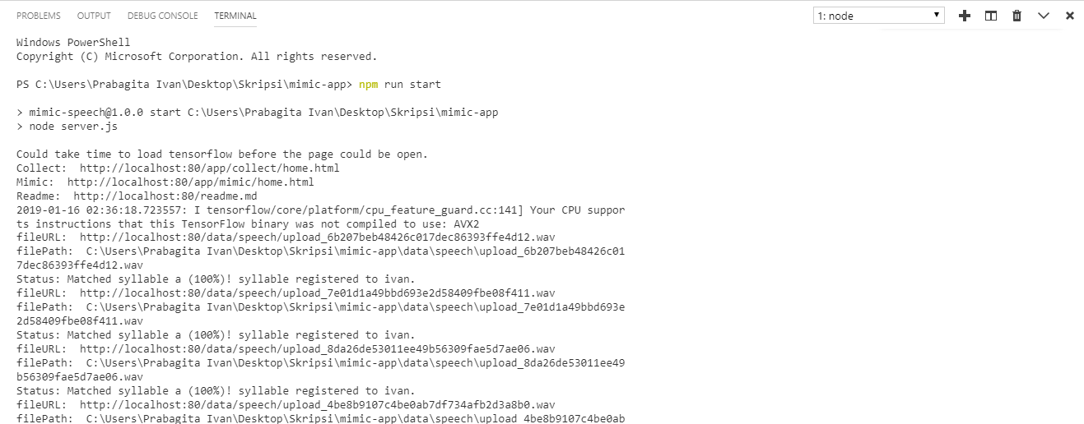

Figures 6.4 Screenshot of Tester 1 with a and i syllables on not noisy background.

Although noisy and semi background on every tester not show a good result, it still can predict about 2 or 3 correct spoken syllables with high accuracy. Not noisy background isn’t guaranteed all spoken syllables are correct even on tester 1 and 2. But, the result is better than noisy and semi background. This is because all the training data is recorded on not noisy background. Also, noise removal or reduction is not applied when extraction process is done before training begin.

Tester 1 and 2 at most moment have good result than tester 3 and 4. But, at some moment tester 3 and 4 have better result than tester 1 and 2. The most good result on tester 1 and 2 is due to the training data is all contain tester 1 and 2. When tester 3 and tester 4 have better result it can be cause by the background condition or the microphone ability to record the speech.

Syllable ma, mu, di, unknown o, and unknown mi have bad result on most time compare to others. The unknown o and mi are caused by the unknown training data is random and mostly background noise instead of focusing o and mi. The machine learning model can’t predict syllable ma, mu, and di well. Most times they have low accuracy but correct prediction or they predict the relative syllable, in example ri or i is the result on di. This can be improved by adding more the training data as the training data is still relatively small. An optimum machine learning model can also improve the result on them and also other syllables as well.

# CONCLUSIONS AND FUTURE WORK

## Conclusion

The following list sums up that the application is achieved based on this research objective:

1. This application enables to recognize speech in Bahasa Indonesia speech from record audio.
2. This application enables to generate speech in Bahasa Indonesia speech from text.
3. This application enables to mimic speech through the website.
4. This application enables to collect speech data through the website.
5. This application enables to train model with collected speech data through the console.

## Future Work

The following suggestion for further development and improvements of the research or application:

1. User Interface

Improvement on UI will always help the user experience. With some colourful theme, clear button or inputs, the application will comfortable to be used.

1. Speech Recognition

Improvement on machine learning model can be made. When there is no right or wrong in modelling the machine learning model, there is always optimal model to get the best prediction and accuracy. A research to find the optimal model to be compare with are big improvement in the application or even in speech recognition itself for mimic speech.

1. Speech Synthesis

Improvement on Speech Synthesis is when generating the speech. By removing some of silence or unused part of the speech and also reducing background will make generated speech more fluently and good to hear. A research in determining Bahasa Indonesia phonemes can be a big improvement since the application use syllables as concatenative synthesis.

REFERENCES

1. wikibooks.org. (2018, February 28). *Introduction to Software Engineering/Process/Rapid Application Development*. Retrieved from Wikibooks: https://en.wikibooks.org/wiki/Introduction_to_Software_Engineering/Process/Rapid_Application_Development
2. Naz, R., & Khan, M. N. (2015). Rapid Applications Development Techniques: A Critical Review. *International Journal of Software Engineering and Its Applications*, 163-176.
3. wikipedia.org. (2018, December 4). *Rapid application development*. Retrieved from Wikipedia: https://en.wikipedia.org/wiki/Rapid_application_development
4. Rabiner, L. R., & Schafer, R. W. (2007). Introduction to Digital Speech Processing. *Foundations and Trends® in Signal Processing*, Volume 1, Issue 1–2.
5. Hande, S. S. (2014). A Review on Speech Synthesis an Artificial Voice Production. *International Journal of Advanced Research in Electrical, Electronics and Instrumentation Engineering*, 8.
6. oxforddictionaries.com. (2018). *syllable*. Retrieved from Oxford Dictionaries: https://en.oxforddictionaries.com/definition/syllable
7. Panitia Pengembang Pedoman Bahasa Indonesia, K. P. (2016). *Pedoman Umum Ejaan Bahasa Indonesia.* Jakarta: Badan Pengembangan dan Pembinaan Bahasa,.
8. M.A.Anusuya, & S.K.Katti. (2009). Speech Recognition by Machine: A Review. *International Journal of Computer Science and Information Security*, 25.
9. Dave, B., & Pipalia, P. D. (2014). SPEECH RECOGNITION: A REVIEW. *International Journal of Advance Engineering and Research*, 7.
10. Sainath, T. N., & Parada, C. (2015). *Convolutional Neural Networks for Small-footprint Keyword Spotting.* New York, NY, U.S.A: Google, Inc.
11. wikipedia.org. (2018, October). *Nyquist–Shannon sampling theorem*. Retrieved from Wikipedia: https://en.wikipedia.org/wiki/Nyquist%E2%80%93Shannon_sampling_theorem
12. Geitgey, A. (2016, December 24). *Machine Learning is Fun Part 6*. Retrieved from Medium: https://medium.com/@ageitgey/machine-learning-is-fun-part-6-how-to-do-speech-recognition-with-deep-learning-28293c162f7a
13. practicalcryptography.com. (2012). *Mel Frequency Cepstral Coefficient (MFCC) tutorial*. Retrieved from Practical Cryptography: http://practicalcryptography.com/miscellaneous/machine-learning/guide-mel-frequency-cepstral-coefficients-mfccs/
14. haythamfayek.com. (2016, April 21). *Speech Processing for Machine Learning: Filter banks, Mel-Frequency Cepstral Coefficients (MFCCs) and What's In-Between*. Retrieved from Speech Processing for Machine Learning: Filter banks, Mel-Frequency Cepstral Coefficients (MFCCs) and What's In-Between: https://haythamfayek.com/2016/04/21/speech-processing-for-machine-learning.html
15. wikipedia.org. (2018, December 7). *Mel-frequency cepstrum*. Retrieved from Wikipedia: https://en.wikipedia.org/wiki/Mel-frequency_cepstrum
16. Hurwitz, J., & Kirsch, D. (2018). *Machine Learning For Dummies®, IBM Limited Edition.* New Jersey: John Wiley & Sons, Inc.
17. Nilsson, N. J., & Laboratory, R. (2005). *INTRODUCTION TO MACHINE LEARNING.* California: Nils J. Nilsson.
18. Society, T. R. (2017). *Machine learning: the power and promise.* London: The Royal Society.
19. Geitgey, A. (2016, Juny 14). *Machine Learning is Fun! Part 3: Deep Learning and Convolutional Neural Networks*. Retrieved from Medium: https://medium.com/@ageitgey/machine-learning-is-fun-part-3-deep-learning-and-convolutional-neural-networks-f40359318721
20. wikipedia.org. (2018, December 26). *Convolutional neural network*. Retrieved from Wikipedia: https://en.wikipedia.org/wiki/Convolutional_neural_network
21. lyrebird.ai. (2018). *Our Voice Products*. Retrieved from Lyrebird: https://about.lyrebird.ai/products
22. translate.google.com. (2018). *Languages*. Retrieved from Google Translate: https://translate.google.com/intl/en/about/languages/
23. w3school.com. (2018). *Node.js Introduction*. Retrieved from W3School: https://www.w3schools.com/nodejs/nodejs_intro.asp
24. mongodb.com. (2018). *NoSQL Databases Explained*. Retrieved from MongoDb: https://www.mongodb.com/nosql-explained
25. muaz-khan. (2019, January 1). *RecordRTC*. Retrieved from Github: https://github.com/muaz-khan/RecordRTC
26. tensorflow.org. (n.d.). *TensorFlow.js*. Retrieved from TensorFlow: https://js.tensorflow.org/
27. tensorflow. (2018, November 30). *tensorflow/examples/speech_commands*. Retrieved from Github: https://github.com/tensorflow/tensorflow/tree/master/tensorflow/examples/speech_commands
28. tfjs-models. (2018, December 22). *speech-commands*. Retrieved from Github: https://github.com/tensorflow/tfjs-models/tree/master/speech-commands
29. jameslyons. (2018, December 20). *python_speech_features/tree/master/python_speech_features*. Retrieved from Github: https://github.com/jameslyons/python_speech_features/tree/master/python_speech_features
30. vail-systems. (2016, December 7). *node-mfcc*. Retrieved from Github: https://github.com/vail-systems/node-mfcc
31. meyda. (2018, December 6). *meyda*. Retrieved from Github: https://github.com/meyda/meyda
32. andreasgal. (2016, August 26). *node-wav*. Retrieved from Github: https://github.com/andreasgal/node-wav
33. vail-systems. (2015, Juny 23). *node-dct*. Retrieved from Github: https://github.com/vail-systems/node-dct
34. pazguille. (2017, February 16). *shuffle-array*. Retrieved from Github: https://github.com/pazguille/shuffle-array
35. sindresorhus. (2014, November 14). *crypto-random-string*. Retrieved from Github: https://github.com/sindresorhus/crypto-random-string
36. felixge. (2018, Juny 25). *node-formidable*. Retrieved from Github: https://github.com/felixge/node-formidable
37. wikipedia.org. (2019, January 2). *List_of_HTTP_status_codes*. Retrieved from Wikipedia: https://en.wikipedia.org/wiki/List_of_HTTP_status_codes